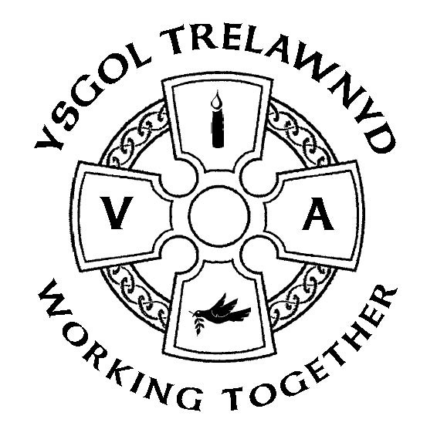

Congratulations Lillia Wade (Year 6) and Daisy Williams (Year 5) - runners up in the Christmas Card competition for Hannah Blythyn AM.
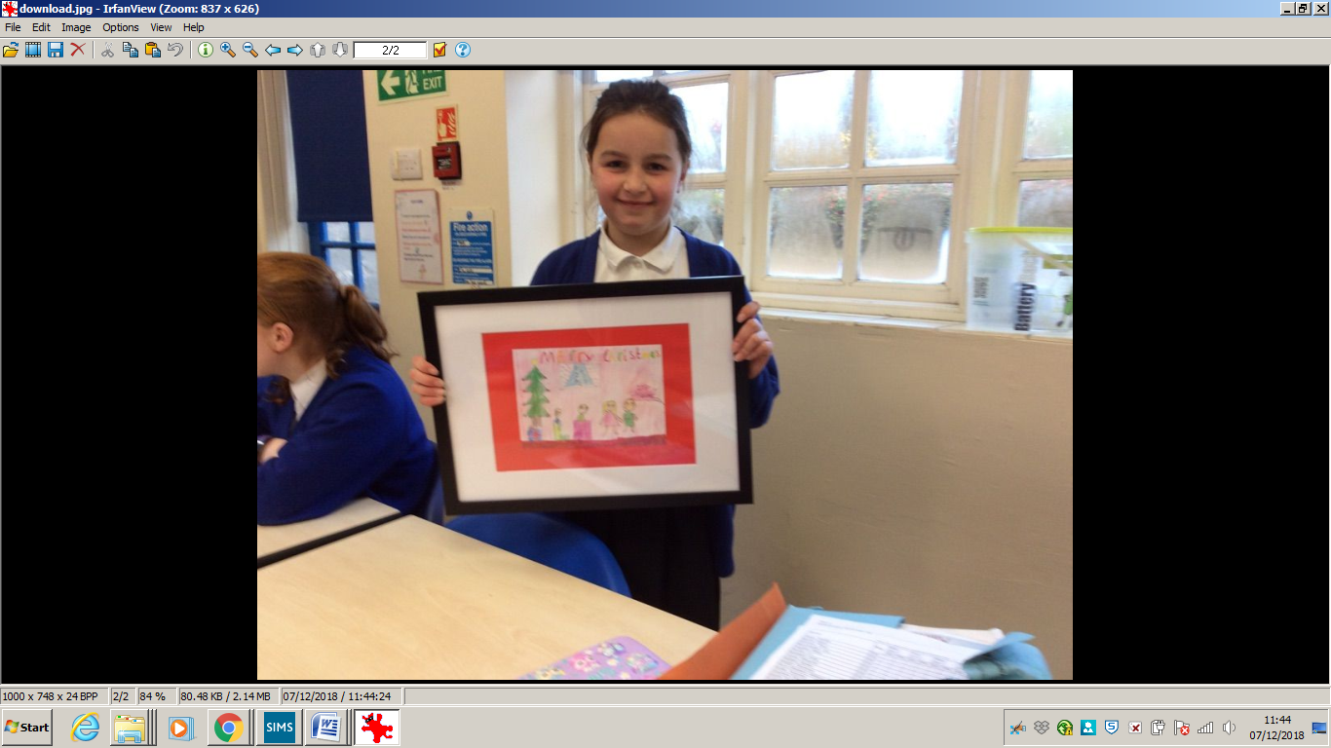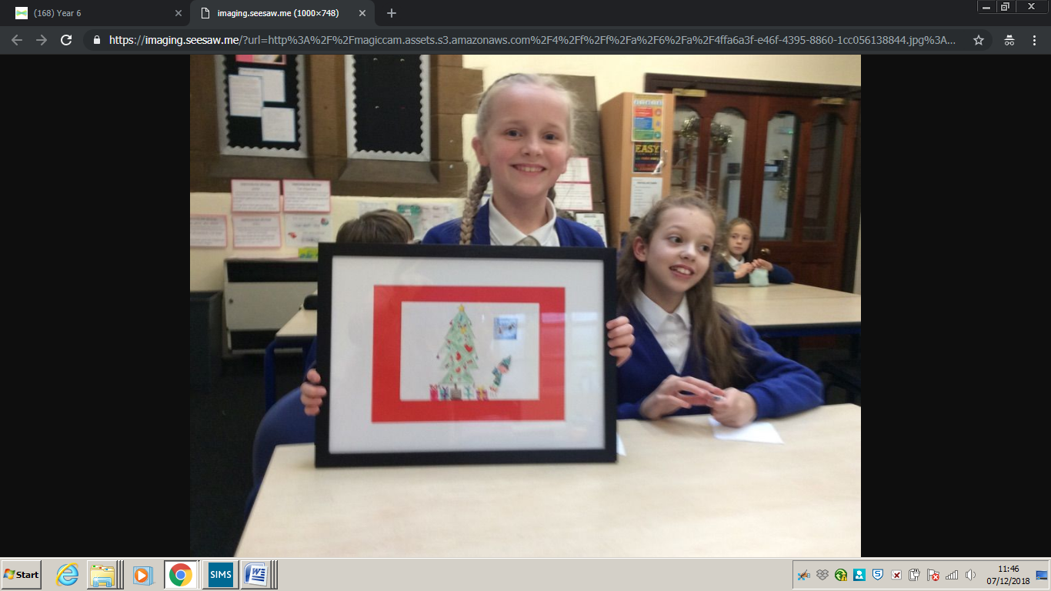

Well Done Lillia Wade (Year 6) who has been chosen to represent Team Wales in the Dance World Cup 2019 in Portugal.

What a busy fortnight…
December
Tue 11th R and Y1/2 trip
Wed 12th Christmas Lunch
Thur 13th PTA event with special visitors 3pm
Tue 18th Y1/2 Christmas Play 6.30pm (Refreshments at 6pm)
Wed 19th KS2 Christmas Play 6.30pm (Refreshments at 6pm)
Thurs 20th Foundation Phase Christmas Party
Thurs 20th KS2 Pantomime trip
Fri 21st Nursery / Reception Nativity Service 10.30am
Fri 21st KS2 Christmas Party
Dates for the diary
January
Tue 15th KS2 Swimming for 5 weeks (£2 for transport)
February
Wed 13th Target Setting
Thur 21st Mini Eisteddfod
Fri 22nd School closed - Training Day
March
Tue 5th Tales from Wales (£1 / child)
Tue 12th Photographs
Wed 25th - Fri 27th Pentrellyncymer (Years 5 and 6)
April
Thur 4th Show and Tell
Fri 12th Easter Service (Years 3 and 4)
ADVANCE NOTICE: National Tests 7th - 14th May 2019

