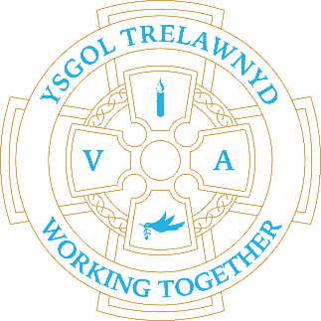
10th January 2024
Blwyddyn Newydd Dda and welcome back to the Spring Term.
We are already back to being busy! ❄️

[Picture removed for online edition]

Please remember we do not have access to our digital systems next week. School lunches should be ordered in school as we will not be able to access the online system. Lunch orders must be placed by 9.15.

On Friday we say ‘Farewell and Good Luck’ to Mrs Jones who is expanding her secretarial horizons and moving on to another school. Mrs Jones has been a stalwart in the school office for many, many years and we wish her all the best. (Obviously, this means responses to office queries may take a little longer whilst we recruit a suitable replacement.)

Before and After School Club
Breakfast Club £2 / After School £10

Activity Clubs until 4pm £2
Monday - Art and Craft
Tuesday - Minecraft
Wednesday - Yoga / Dance
Thursday - ICT

PLACES MUST BE BOOKED IN ADVANCE BY EMAIL: trelawnydlittlelearners@gmail.com

Account Name: Trelawnyd Little Learners
Sort Code: 40 - 30 - 07
Account Number: 31898892

All payments MUST be made weekly

Dates for your diary:
School closes for half term: Friday 9th February

Cofion,
Marina Parsons
Pennaeth / Headteacher
01745 570171
trhead@hwbcymru.net

