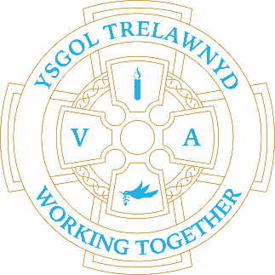
10th October 2022

[Picture removed for website edition]

Thank you to Years 1 and 2 who reminded us to be thankful for all the lovely produce we have at Harvest time.

As we continue to return to a more usual school year, as always, we focus our expectations in terms of the children’s learning. This year we are looking to improve our attendance and punctuality rates as a school priority. Whole school attendance is 91.6% - well below the expected 96% and we will be regularly reporting on attendance this year.
Please call the school office 01745 570171 or send a message on SeeSaw if your child is absent from school; unexplained absences are marked as unauthorised.

We also need to ensure our learning environment is safe and secure. This requires us to lock the gates at the beginning of the day. There is, therefore, no access to the rear of school after 8.55am when school starts and the gates are locked, any late-comers need to use the main front door after this time.
I am aware of the inconvenience of the rear gate being locked if you park at the rear of school, or live in the village and walk. We do leave this as the last gate to be locked. There is limited staff capacity to be able to lock the gates later in the morning, any suggestions will be considered.

Dates for your diary:
Thank you for your donations - Harvest Collection deadline is 14th October
21st October: Show Racism the Red Card and wear red
26th October: Target Setting

CYMRAEG YR WYTHNOS
Cymraeg plant: Stopiwch!
Cymraeg oedolion: Brysiwch!

Cofion,
Marina Parsons
Pennaeth / Headteacher
01745 570171
trhead@hwbcymru.net

Before and After School Provision available - 01745 856683
Before School 8am-8.50am £2.00 / After School Until 5.30pm £9

Pre-loved uniform is available

[Pictures removed for website edition]

Our first PTA meeting of 2022/23 will be Monday 17th October 6.30pm at The Crown.
If anyone is interested in any aspects of Trelawnyd PTA whether that is helping at an event, ideas or attending meetings.
At this meeting we can run through what is usually organised in a year, any ideas for raising money for PTA events, set dates and times each half term to keep on top of the events planned.
Anyone welcome, any involvement big or small is very appreciated.

