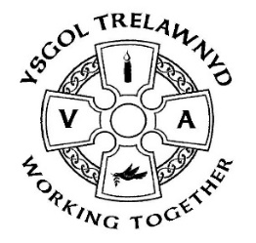
11th December 2020
URGENT MESSAGE:
Dear Parents / Carers,
On the advice of Flintshire Local Authority and in consultation with the Chair of Governors, to ensure the safety of all, a decision has been made to close school on Wednesday 16th December. For the remaining two days of term, teaching staff will provide blended learning activities.
Staff will make Childcare provision for Key Workers’ and vulnerable pupils on Thursday (8.45-3.00) and Friday (8.45-1.15). If you need to access this childcare, then please email trhead@hwbcymru.net by Monday 14th December for a registration form. Please only access this care if you have no other safe alternative for your child/ren.
I appreciate that this is very short notice, but this is an ever-changing situation and one in which we need to ensure that we are making the best decisions for everyone, with the safety and well-being of all a priority.
I thank you for your support and understanding at a time when we are all challenged by events beyond our control.
Miss M Parsons

The School Council planted over 20 trees this week as part of Trees for Schools. They are hoping to get a soundbite on Countryfile’s ‘Plant Britain’ challenge
(Pictures removed for website version)

This term, Mrs L Hoggarth has joined our team as a Learning Support Assistant in Y1/2. As always, the children have made her feel very welcome

Reminders:
KS2 (Years 3-6) please remember you should not share your snacks on the yard
If your child hasn’t already, please log in to 'Bug Club', our new online reading resource - let your teacher know if you cannot access it
Christmas Dinner: Wed 16th December – Party clothes may be worn (but remember sensible footwear for outside please)

Kind regards,
Marina Parsons
Pennaeth / Headteacher
01745 570171
trhead@hwbcymru.net

