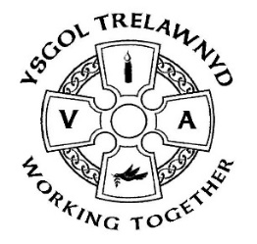
13th November 2020

Parents Evening: It was lovely to catch up with some of you this week. Thank you for your positive comments about how well your children have settled back into school.

Hwb trials: We have been invited to participate in the online trials for the new reasoning maths test. From Monday 2 November to Friday 4 December, each pupil from Year 2 to Year 6 will take one linear assessment. The purpose of this trial is to calibrate the difficulty of the questions. Our learners will play an important role in developing the new assessments, provide essential feedback and see the question types that will be used in the live assessments. The trial materials will be accessed through Hwb at school. Further information can be found at: https://hwb.gov.wales/curriculum-for-wales/reading-and-numeracy-assessments/personalised-assessments/

School Session Times: Some parents have been enquiring about the times of the school day. Welsh Government have issued a fourth notice temporarily disapplying regulations 3 and 4 of the Changing of School Sessions Times (Wales) Regulations 2009. The notice came into force on 1 November 2020. This temporary disapplication will only apply to changes to session times made due to the incidence of coronavirus and any changes made whilst the notice has effect will not be permanent.
https://gov.wales/changes-school-session-times-coronavirus
We have shortened our lunch break to accommodate the changes to the start and finish times of the school day to ensure leaners are receiving the appropriate amount of teaching time and there is a balance of time spent outdoors for learning and play.

Show and Tell: The children are busy preparing a ‘virtual Show and Tell’ as they are not able to share their learning ‘face to face’ this term. Class films will be uploaded to SeeSaw on Thursday 26th.

Thank you: The Smarties Challenge raised £365 for PTA funds – thank you!

Thank you for your generosity in supporting the School Council in their Christmas Shoebox Appeal; we are able to make at least 13 boxes!!

Reminders:
Please return Contact Details Forms to Mrs Jones as soon as possible to enable us to update our records

The closing date for applications to our Reception class is Friday 20th November.

Take care and stay safe.
Kind regards,
Marina Parsons
Pennaeth / Headteacher
01745 570171
trhead@hwbcymru.net

(Pictures removed)

