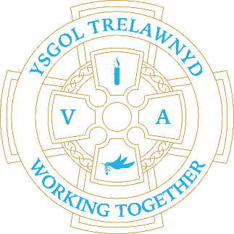
16th October 2023

[Picture removed for website edition]

Nursery children picked apples from the gardens this week and the Early Years class made apple crumble – delicious!

THIS IS THE LAST WEEK OF School Clubs
Monday - Construction
Tuesday - Films
Wednesday - Outdoors / Sports
Thursday - Arts/Crafts

Cymraeg yr wythnos:
Ga i.. (bencil/bapur/ siswrn etc.) | Wyt ti eisiau..?

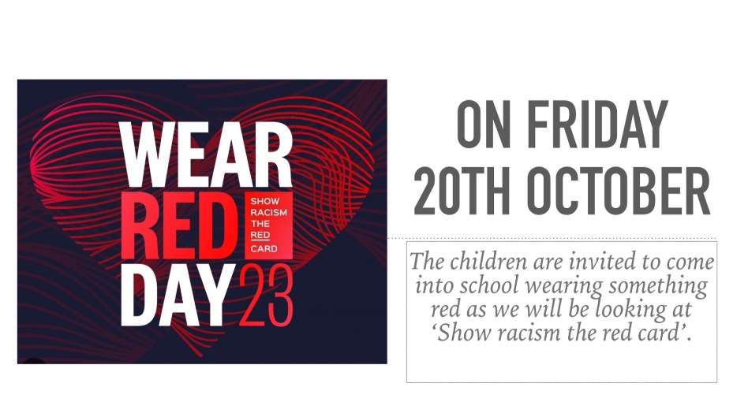

Dates for your diary:
25 / 10 Target Setting
26 / 10 PTA Autumn Disco 5.30pm-7pm
6 / 11 Training Day
7 / 11 School opens
23 / 11 PTA Movie Night 3-5.30pm
30 / 11 Show and Tell 3pm
7 / 12 Chester Zoo trip (Rec – Y6)
8 / 12 Christmas Jumper Day
13 / 12 Carol Concert at Memorial Hall 6pm-7pm
19 / 12 FP (Rec-Y2) Christmas Play (afternoon and evening performance)
20 / 12 Y3-6 Christmas Play (afternoon and evening performance)
21 / 12 Early Years Nativity 10.30am at Llanasa Church
22 / 12 School closes for the Christmas holidays
Details for events will follow nearer the time

10 / 1 / 2024 School opens

Cofion,
Marina Parsons
Pennaeth / Headteacher
01745 570171
trhead@hwbcymru.net

Pre-loved uniform is available

Forms requesting holiday in term time are available from the class teachers or school office and should be completed in advance. Currently, school will authorise 10 days leave only.

Please inform school on the first day of absence 01745 570171 / trhead@hwbcymru.net

