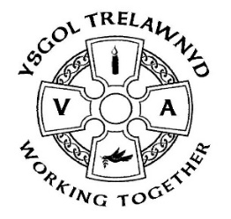
16th April 2021

And the sun is shining for the Summer Term!

[Pictures removed for website edition]

Welcome back everyone!

Newydd School Meals
The ‘School meals for £2’ initiative runs until the end of April. From 1st May the price of school meals will increase to £2.30.

PTA Meeting Monday 19th April
Please see the School or PTA Facebook pages for more information; any Covid-safe ideas for events would be much appreciated

PE: (please wear your kit to school)
Nursery and Reception: Wednesday
Years 1 and 2: Tuesday
Years 3 and 4: Thursday
Years 5 and 6: Friday

We have finally welcomed Miss Darby Higgins for her teacher training placement, deferred from January. I am certain she will enjoy her time with Years 1 and 2.

Summer Term dates for your diary:
28th May School closes for the half term break
7th June School re-opens
15th June School Photographs (provisionally booked)

The Hut is looking fantastic. It will eventually be enclosed; there has been a delay receiving the doors and windows. (I don’t think the builders appreciated my comment that maybe they were stuck in the Suez Canal.)

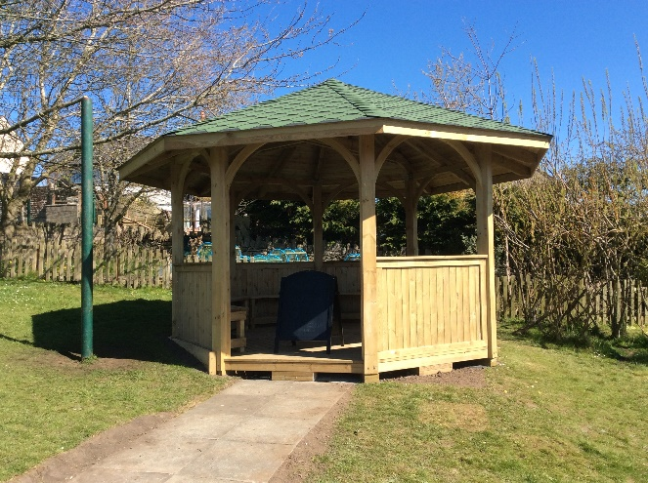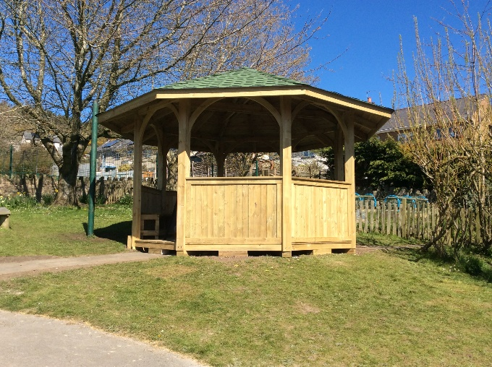

Marina Parsons
Pennaeth / Headteacher
01745 570171
trhead@hwbcymru.net

