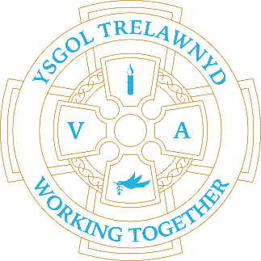
17th October 2022

All classes enjoyed a great Coding workshop last week from Technocamps.

[Pictures removed for website edition]

This week is the last week of School Clubs until after half term.

CYMRAEG YR WYTHNOS
Cymraeg plant: Ga i…?
Cymraeg oedolion: Wyt ti eisiau…?

Dates for your diary:
21st October: Show Racism the Red Card and wear red
26th October: Target Setting
28th October school closes for half term
7th November school opens

Cofion,
Marina Parsons
Pennaeth / Headteacher
01745 570171
trhead@hwbcymru.net

Before and After School Provision available - 01745 856683
Before School 8am-8.50am £2.00 / After School Until 5.30pm £9
Pre-loved uniform is available

