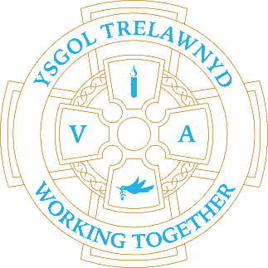
18th December 2023

[Picture removed for website edition]

Christmas Plays - performances will be held in the School Hall
Matinée Performance 2pm - Doors open 1.45pm
No refreshments
Evening Performance 6.15pm - Doors open 5.45pm
Refreshments (free) served until 6.10pm
Entrance for the plays will be through the side green gate only
Please do not try to access school from the yard or rear doors
For the afternoon performance please use the rear slope or front steps
For the evening performance entry is via the front steps only

Dates for your diary:
18th December - Christmas Grotto - Years 3 and 4
19th December - Bethlehem Bake Off - Years 1 and 2
20th December - Christmas Around the World - Years 5 and 6
21st December at 10.30am - The Nativity at Llanasa Church - Nursery/Reception
21st December Class Christmas Parties
22nd December School closes for the Christmas break

Wednesday 10th January 2024 School opens for the Spring Term

Cofion,
Marina Parsons
Pennaeth / Headteacher
01745 570171
trhead@hwbcymru.net

Pre-loved uniform is available

Forms requesting holiday in term time are available from the class teachers or school office and should be completed in advance.

Please inform school on the first day of absence 01745 570171 / trhead@hwbcymru.net

