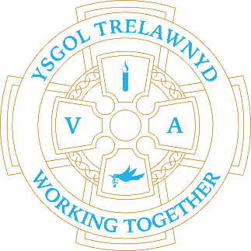
18th September 2023

School Clubs until 4pm.
Monday - Construction
Tuesday - Films
Wednesday - Outdoors / Sports
Thursday - Arts/Crafts

Cymraeg yr wythnos:

Dw i’n hoffi… | Mae’n amser chwarae.

Dates for your diary:
The first PTA meeting of the year will take place on Thursday 21st September at 2.15pm at school. All welcome. (Times for the meetings will vary throughout the year)
29 / 9 Liverpool Museum (Reception / Yrs 5 and 6)
25 / 10 Target Setting
6 / 11 Training Day
30 / 11 Show and Tell 3pm
7 / 12 Chester Zoo trip (Rec – Y6)
8 / 12 Christmas Jumper Day
19 / 12 FP Christmas Play
20 / 12 Y3-6 Christmas Play
21 / 12 Early Years Nativity
Details for events will follow nearer the time

Cofion,
Marina Parsons
Pennaeth / Headteacher
01745 570171
trhead@hwbcymru.net

Pre-loved uniform is available

Forms requesting holiday in term time are available from the class teachers or school office and should be completed in advance. Currently, school will authorise 10 days leave only.

Please inform school on the first day of absence 01745 570171 / trhead@hwbcymru.net

