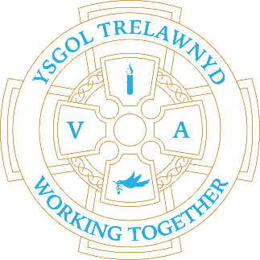
19th December 2022

What a great Christmas Carol Concert the children held at Memorial Hall last Thursday. It was lovely to see so many of you. Thank you for braving the weather.

[Picture removed for website edition]

CYMRAEG YR WYTHNOS
Cymraeg plant: Dim ots!
Cymraeg oedolion: Ffwrdd â chi!

We have been given £125 to spend on our garden for taking part in the Llanasa Bee Festival. We are going to create some signs for our gardening area.

[Picture removed for website edition]

Dates for your diary:
19th December Y56 Play - Archibald’s War - 1.30pm / 6.30pm (Refreshments at 6pm)
20th December Y34 Play - Christmas is Forever - 1.30pm / 6.30pm (Refreshments at 6pm)
21st December Y12 Play - A Midwife Crisis - 1.30pm / 6.30pm (Refreshments at 6pm)
(There are no refreshments served during the afternoon Dress Rehearsal performances)
22nd December Early Years - The Nativity 9.30am (Refreshments at 9am)

Welsh Government have allocated an additional INSET day. This will be Thursday 20th July. School will now close for the Summer on Wednesday 19th July.

Cofion,
Marina Parsons
Pennaeth / Headteacher
01745 570171
trhead@hwbcymru.net

Before and After School Provision available - 01745 856683
Before School 8am-8.50am £2.00 / After School Until 5.30pm £9

Pre-loved uniform is available

Forms requesting holiday in term time are available from the class teachers or school office and should be completed in advance

Please inform school on the first day of absence 01745 570171 / trhead@hwbcymru.net

