

20th December 2018

Years 1 and 2 started the Christmas celebrations by performing Christmas songs at Lido Grange, Prestatyn.
Thank you to the PTA for organising the reindeer surprise for the children (and adults)

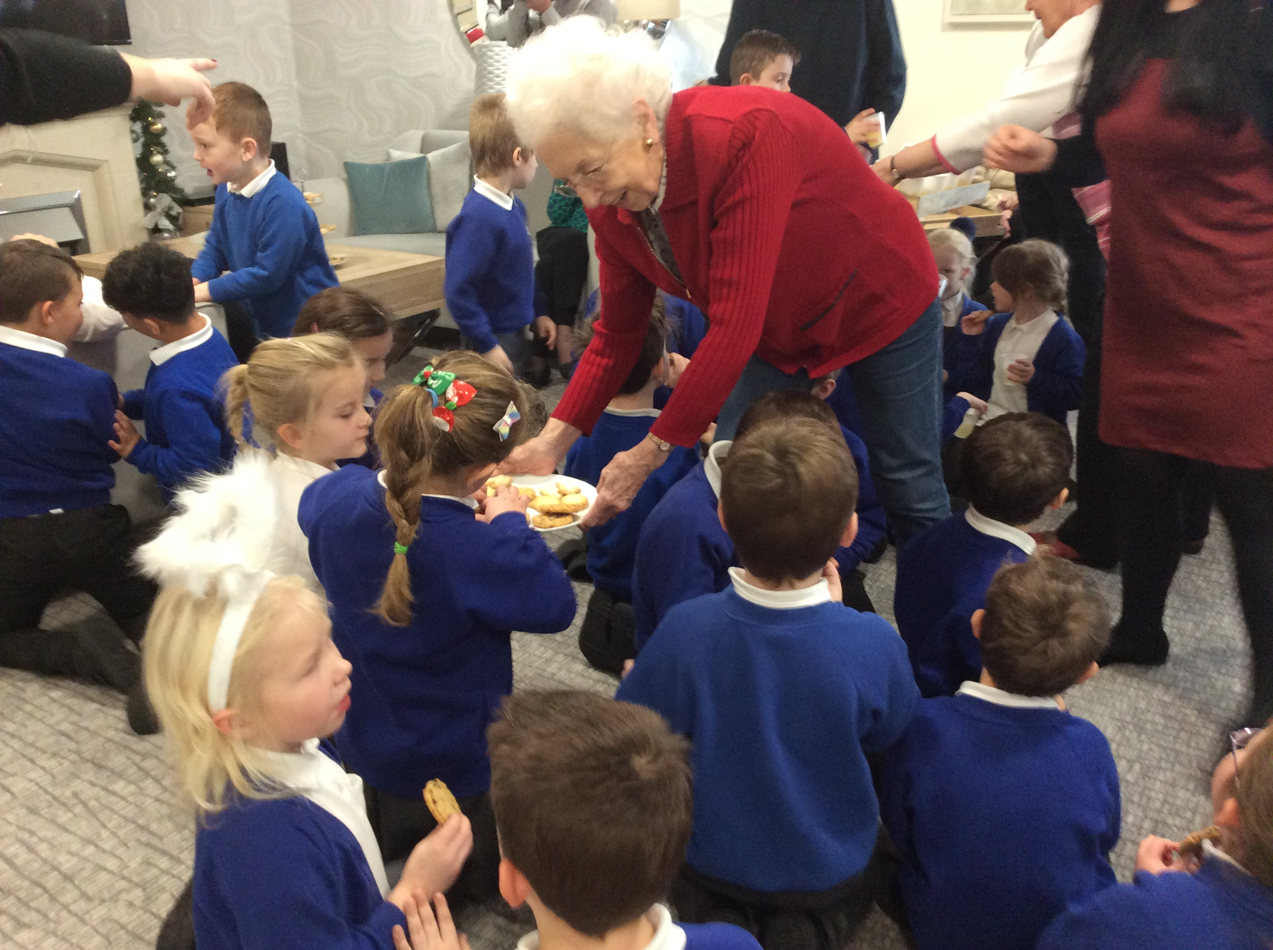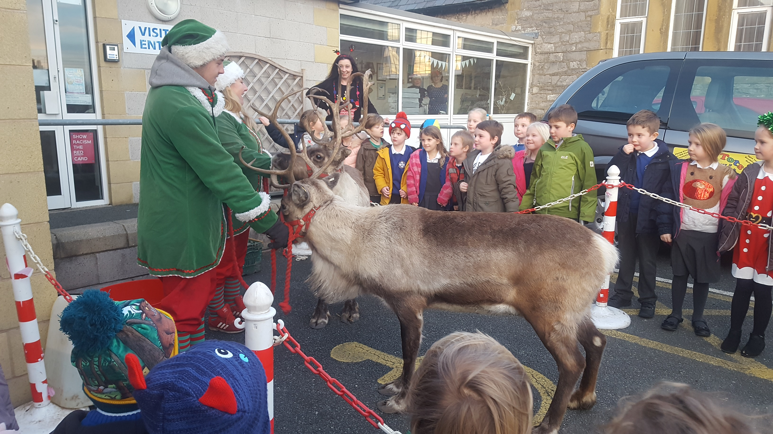

What fantastic performances! The Christmas productions raised £529

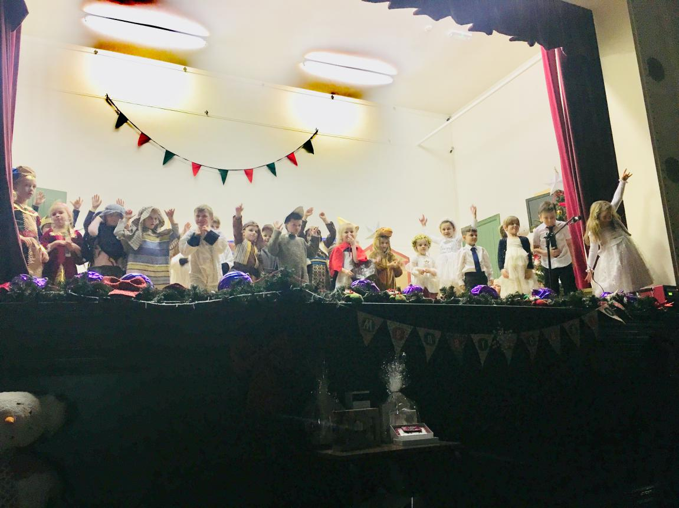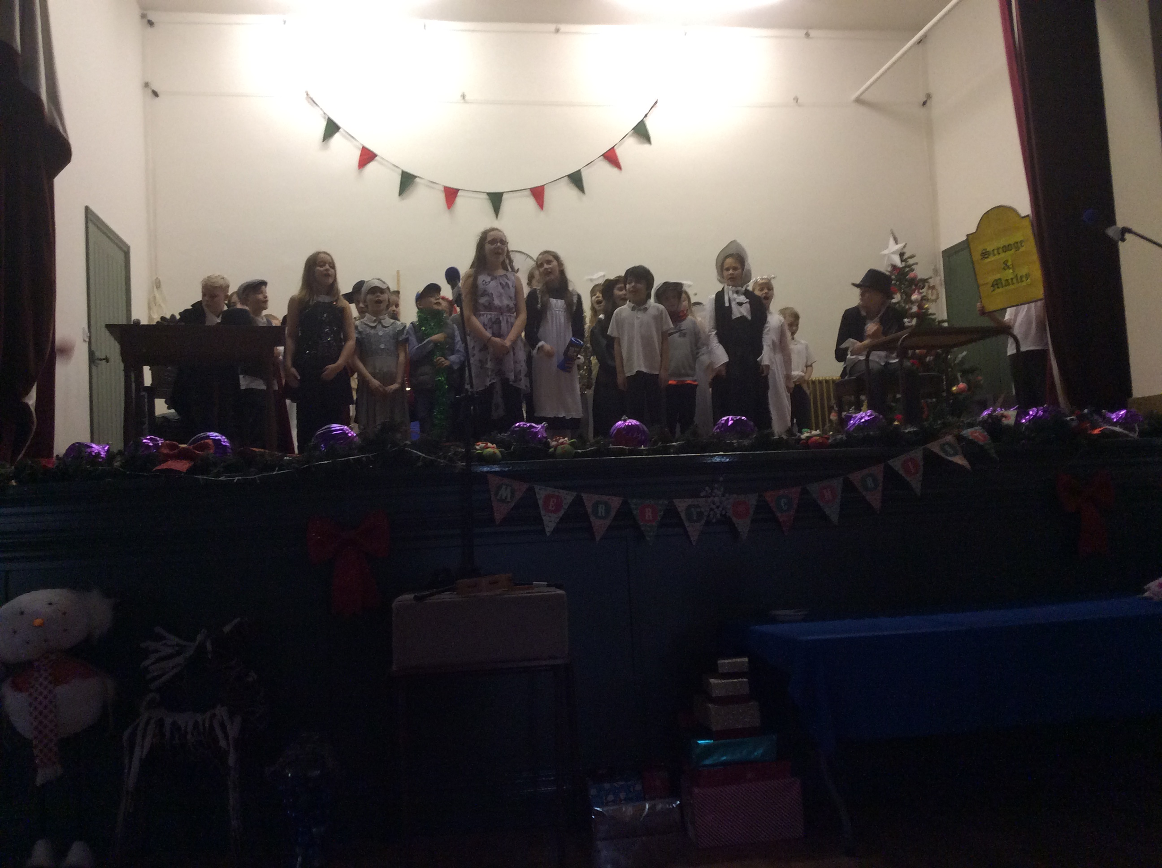

The children in Nursery and Reception have chosen ‘Are we nearly there?’ as their next topic. They will be investigating travel and different forms of transport. Please collect any boxes, wrapping paper tubes and bubble wrap that would help with junk modeling. Holiday brochures would be good too!

Year 1 & 2's new topic will be 'Muck, Mess & Mixtures’ and as part of the topic will be looking at hazards and labeling. Please save any cleaning or medicine bottles that you finish over the Christmas holidays, e.g. window cleaner, calpol, etc. The adults will ensure the bottles are safely secured and we will be using them to compare hazardous labels and safety information during the spring term.

Year 3 and 4 have chosen ‘Predators’ as their new topic.

The Year 5 and 6 topic will be ‘Gallery’.

Clubs for Spring Term
Monday - Craft
Tuesday - Animation
Thursday - PE / Games

Wishing you all a Merry Christmas and peaceful New Year!

Tiny Tots Holiday Club is open 2nd - 4th January

Dates for the diary
January
Mon 7th School opens for the Spring term
Tue 15th KS2 Swimming for 5 weeks (£2 for transport)
February
Wed 13th Target Setting
Thur 21st Mini Eisteddfod
Fri 22nd School closed - Training Day
March
Tue 5th Tales from Wales (£1 / child)
Tue 12th Photographs
Mon 25th-Wed 27th Pentrellyncymer (Years 5 and 6)
April
Thur 4th Show and Tell
Fri 12th Easter Service (Years 3 and 4)
ADVANCE NOTICE - National Tests 7th-14th May 2019

