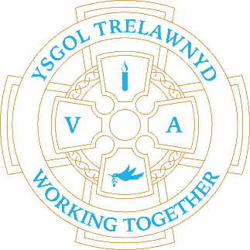
20th November 2023

Today the scaffolding is being re-erected at the side of the building to undertake remedial works to the roof once again.
The side access to school is out of use; access to school will be through the rear gate or up the slope and across the playground.
Breakfast and After School drop off and collection at the front door, as usual.
Please DO NOT USE the car park after 8.30am or before 4pm

School Clubs
Monday - Animation (Mr Williams)
Tuesday - Science (Mrs Richards)
Wednesday - Draw with Rob (and Mrs McNamara)
Thursday -There is no Dance Club this week as it’s Movie Night

Thank you for your support at the recent PTA events. The Autumn Disco raised £120 and the Smarties Challenge £142.08; the class challenge was won by Y12.

The School Council donated £37.91 to Children in Need. Diolch, pawb!

Dates for your diary:
23 / 11 PTA Movie Night THE GRINCH 3-5.15pm
30 / 11 Show and Tell 3pm
7 / 12 Chester Zoo trip (Rec – Y6)
8 / 12 Christmas Jumper Day
13 / 12 Carol Concert at Memorial Hall 6pm-7pm
19 / 12 FP (Rec-Y2) Christmas Play (afternoon and evening performance)
20 / 12 Y3-6 Christmas Play (afternoon and evening performance)
21 / 12 Early Years Nativity 10.30am at Llanasa Church
22 / 12 School closes for the Christmas holidays
Details for events will follow nearer the time

10 / 1 / 2024 School opens

Cofion,
Marina Parsons
Pennaeth / Headteacher
01745 570171
trhead@hwbcymru.net

Pre-loved uniform is available

Forms requesting holiday in term time are available from the class teachers or school office and should be completed in advance. Currently, school will authorise 10 days leave only.

Please inform school on the first day of absence 01745 570171 / trhead@hwbcymru.net

