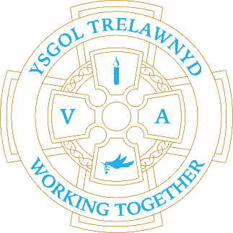
21st November 2022

The Early Years and Years 5/6 classes enjoyed brilliant Size of Wales workshops this week.
‘An area the size of Wales’ is frequently used to measure the rate of forest destruction. Size of Wales encourages the people of Wales to help tackle climate change by taking simple positive actions; they work with schools to raise awareness of the importance of forests in tackling climate change.

[Pictures removed for website edition]

Kayla: I really liked the afternoon with Jodie, my favourite part was blasting off our message bottles. My message bottle was about raising awareness to stop cutting down the rainforest to make space for farmland.
Charlie PG: I really enjoyed working as a team to make the bottles to blast off.
Bethany: I really enjoyed the session; it brightened up my afternoon. It really made me think about what is happening to the rainforests and I learnt a lot.
Poppy: I enjoyed being creative and thinking about how we could decorate our bottle to show our message. I also liked blasting the bottles.
Sam: It was really interesting, and I liked getting into groups and working together. I didn't know that Lemurs have been around since prehistoric times and have changed over time. I learnt a lot of new stuff.
Phoebe: I really enjoyed creating the world on the field and finding out where all the rainforests are in the world.

CYMRAEG YR WYTHNOS
Cymraeg plant: Beth wyt ti’n feddwl o…?
Cymraeg oedolion: Un, dau, tri… (using number words)

Dates for your diary:
25th November Eco Council Fairtrade own clothes day
1st December Show and Tell for all classes 3pm
3rd December Llanasa Church Christmas Fayre 1pm-4pm
8th December Christmas Jumper Day
14th December Christmas Lunch
15th December Carol Concert 3pm
19th December Y56 Play 1.30pm / 6.30pm
20th December Y34 Play 1.30pm / 6.30pm
21st December Y12 Play 1.30pm / 6.30pm

Cofion,
Marina Parsons
Pennaeth / Headteacher
01745 570171
trhead@hwbcymru.net

Before and After School Provision available - 01745 856683
Before School 8am-8.50am £2.00 / After School Until 5.30pm £9

Pre-loved uniform is available

Forms requesting holiday in term time are available from the class teachers or school office and should be completed in advance
Please inform school on the first day of absence 01745 570171 / trhead@hwbcymru.net

