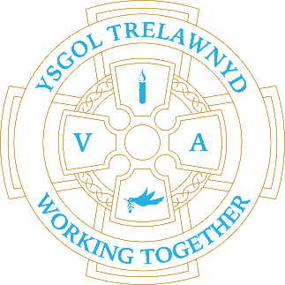
24th October 2022

Thank you to everyone who popped their blue tokens into the Trelawnyd Box in Tesco, Prestatyn. We came 2nd, which has secured us £1000 towards our wellbeing area.

This year we are monitoring attendance: Whole School Target: 96% / Current: 91.7%
Individual letters will be shared at Target Setting on Wednesday
Rec: 89.3%
Y1: 87.9%
Y2: 88.1%
Y3: 94.6%
Y4: 87.1%
Y5: 94.3%
Y6: 94%

NO School Clubs this week
Clubs will restart wc 7th November for 5 weeks:
Mon: Indoor Games (Mrs Bayliss)
Tue: Welsh animation (Mr Williams)
Wed: Forest School (Mrs McNamara)
Thur: Christmas Choir (Miss Hughes)

CYMRAEG YR WYTHNOS
Cymraeg plant: Beth wyt ti’n hoffi bwyta?
Cymraeg oedolion: Ysgrifennwch!

Forms requesting holiday in term time are available from the class teachers or school office and should be completed in advance

Please inform school on the first day of absence 01745 570171 / trhead@hwbcymru.net

Please can all dinner money be paid on a weekly or fortnightly basis

Dates for your diary:
28th October school closes for half term
7th November school opens
Remembrance Day: The children will place two wreaths on the memorial outside Trelawnyd Village Hall, one from Ysgol Trelawnyd and one from Trelawnyd Youth Club.
18th November Flu vaccinations

Cofion,
Marina Parsons
Pennaeth / Headteacher
01745 570171
trhead@hwbcymru.net

Before and After School Provision available - 01745 856683
Before School 8am-8.50am £2.00 / After School Until 5.30pm £9
Pre-loved uniform is available

PTA Event

[Pictures removed for website edition]

The Eco Council would like to share their posters to encourage everyone to be eco-friendly

