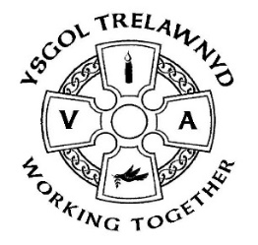
25th June 2021

Miss Higgins has successfully completed her placement with Years 1 and 2 and we all wish her ‘Pob Lwc’ as she completes degree course.

Following the success (and fun) of the Eco Council’s Water Day, the Ethos Council are planning a Spirituality morning for all classes on 8th July.

[Pictures removed for website edition]

This week the Juniors made it to Lisbon. As part of their Daily Mile they are taking part in a 'Race around Europe' event this term. Starting at Deeside, they have travelled via London and Paris to reach Lisbon and are hoping to get to one more city before the end of term.

On Monday 12th July, KS2 have a skateboarding workshop (please wear PE kit to school on that day).

Thank you for your support - the plant sale raised £130.

[Pictures removed for website edition]

There is an online PTA meeting on Monday 28th June at 6.30pm via Zoom; please contact Joanne Emslie for further information or to share ideas.

[Pictures removed for website edition]

The PTA have arranged for a Clothing Bank to be delivered. It is at the front of school should you have any items to donate.

Cofion,
Marina Parsons
Pennaeth / Headteacher
01745 570171
trhead@hwbcymru.net

Summer Term dates for your diary
2nd July Reports
16th July last day of term
19th July Training Day
20th July Training Day
(Thursday 2nd September - first day of the new school year)

