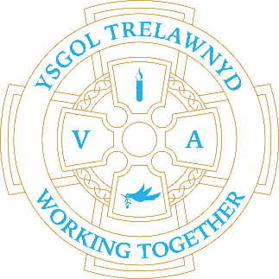
26th September 2022

Emma McCulloch visited Blwyddyn 1 a 2 to answer their questions about her job and role as a real-life superhero!

[Pictures removed for website edition]

PC Manus talked about people who help us with Nursery and Reception

Dates for your diary:
7th October: Y12 Harvest Festival 2.30pm
21st October: Show Racism the Red Card and wear red
26th October: Target Setting
Thank you for your donations - Harvest Collection deadline is 14th October

[Pictures removed for website edition]

Cofion,
Marina ParsonsPennaeth / Headteacher
01745 570171
trhead@hwbcymru.net

Before and After School Provision available - 01745 856683
Before School 8am-8.50am £2.00 / After School Until 5.30pm £9

Pre-loved uniform is available

