26th March 2021

What a fabulous fortnight we have had with all the children returning to school. We celebrated Red Nose Day last Friday, with various members of staff receiving some extra face paint ‘tweaks’ to their face coverings during the day. Thank you for your donations.

Years 5 and 6 have been busy pH testing
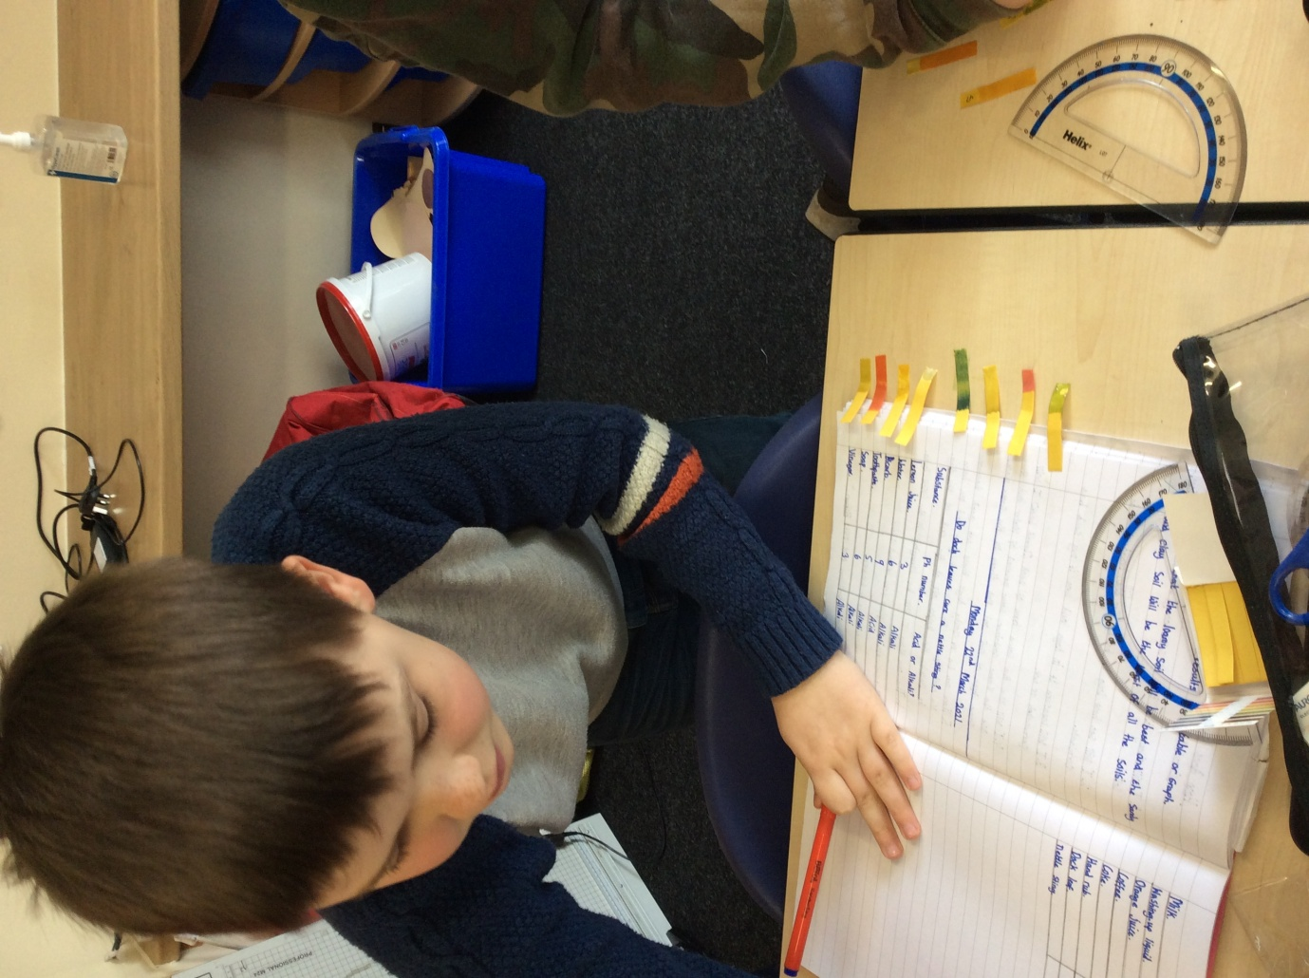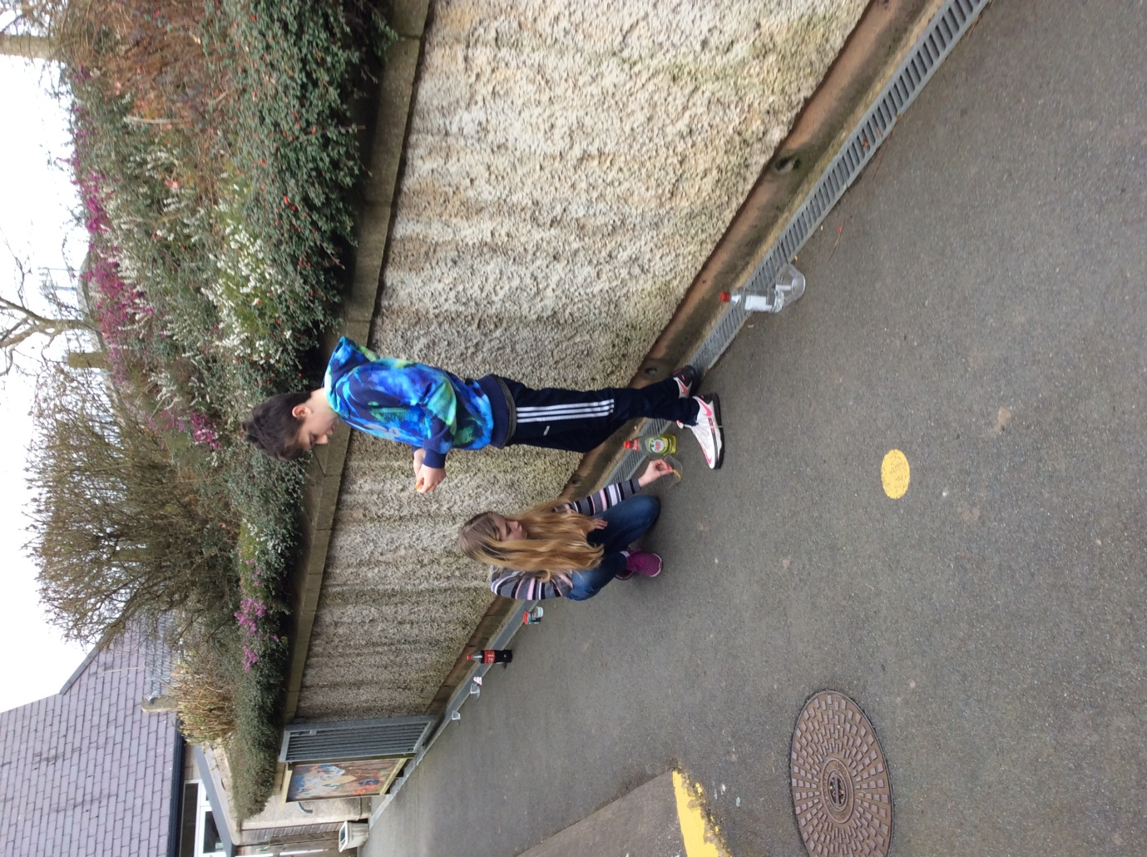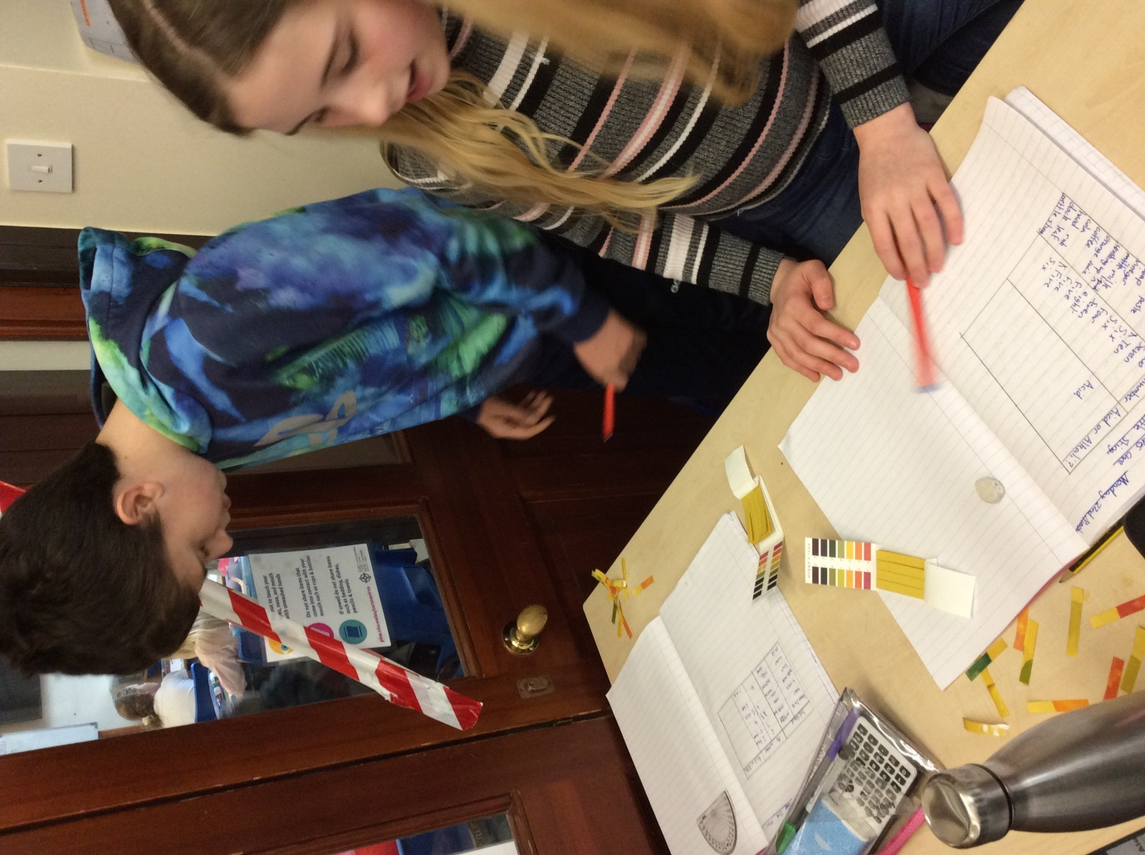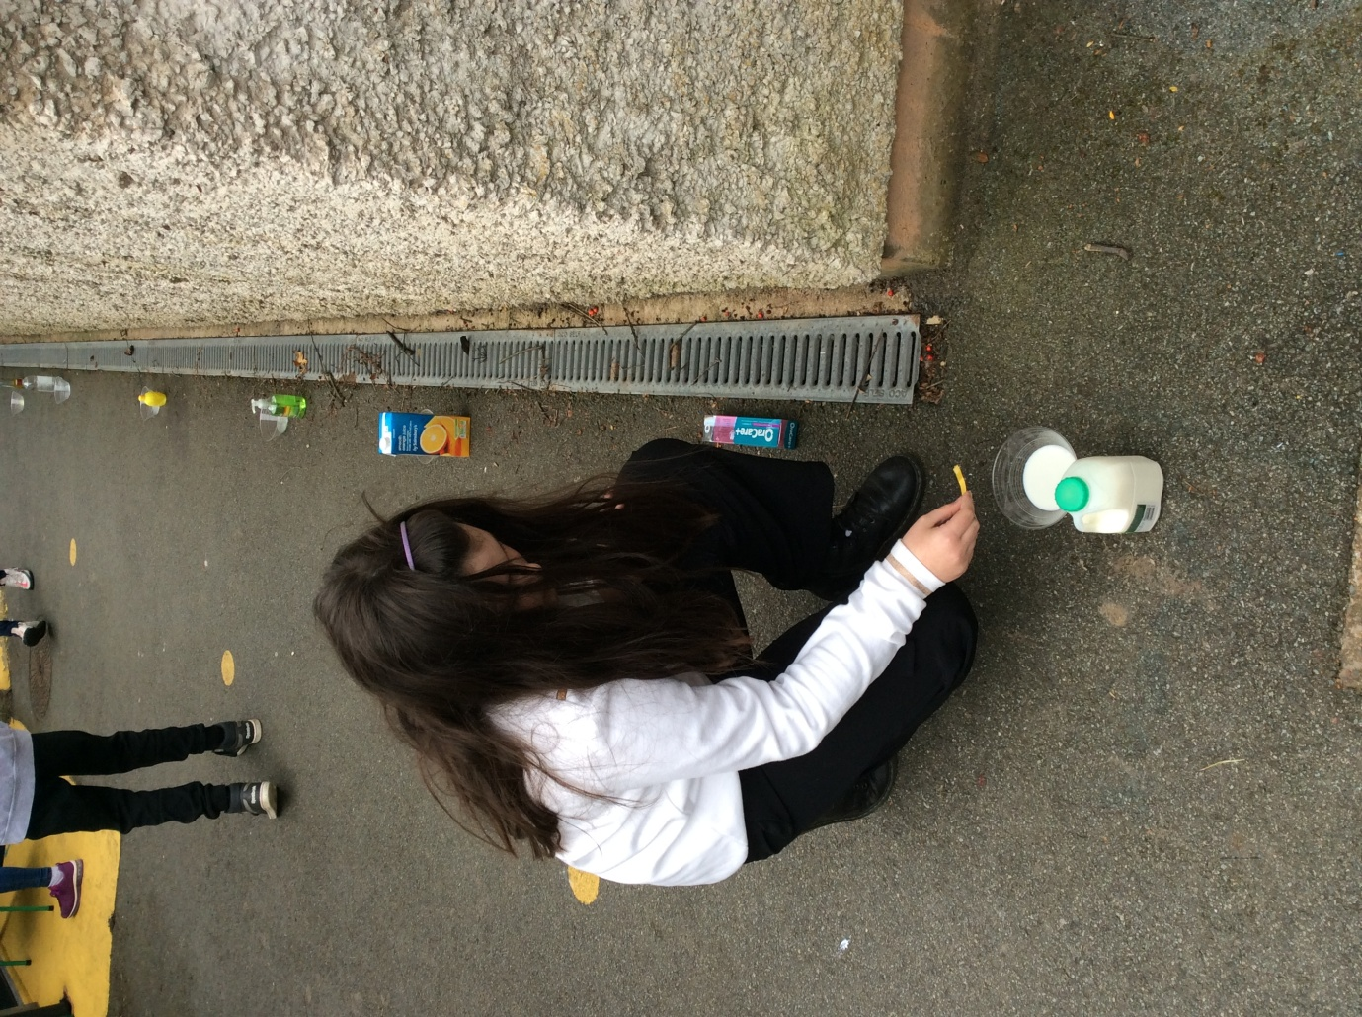

Thank you to the PTA and everyone involved in organising an Easter Egg Hunt today and donating chocolate eggs for all the children. We have also seen a marvel of colourful bonnets and decorated eggs today.

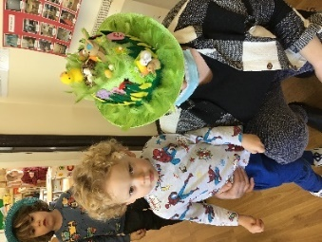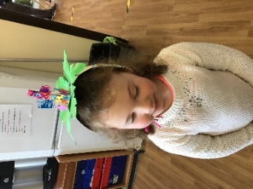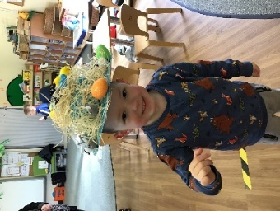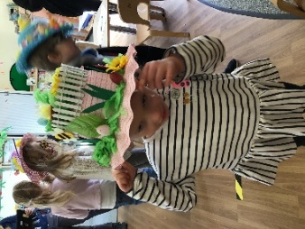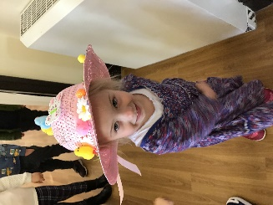

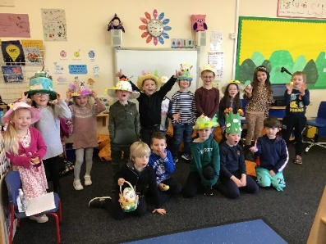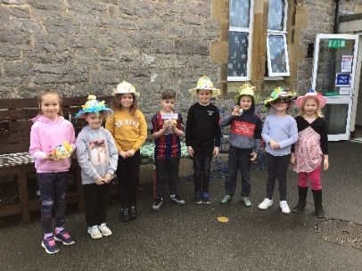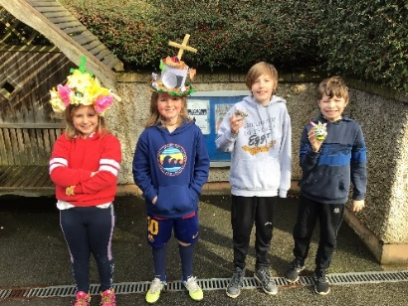

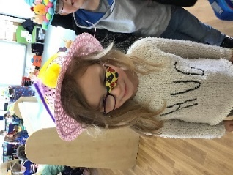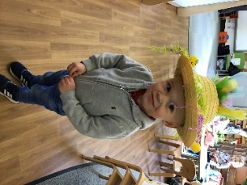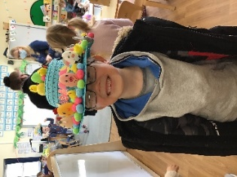
Topics for the Summer term will be:
Nursery and Reception: Rockpools and Beaches
Years 1 and 2: The Scented Garden
Years 3 and 4: Potions
Years 5 and 6: Frozen Kingdom

School uniform should be worn for the Summer term
PE: (please wear your kit to school)
Nursery and Reception: Wednesday
Years 1 and 2: Tuesday
Years 3 and 4: Thursday
Years 5 and 6: Friday

Summer Term dates for your diary:
School re-opens for the Summer term on Tuesday 13/4/2021
School closes for the half-term break 28/5/2021
School opens 7/6/2021
School closes for the summer 16/7/2021

Drop off and Pick-up will remain the same after the Easter break
8.40 KS2 children only / 8.45 mixed FP/KS2 sibling groups / 8.50 Foundation Phase children only
3.05 Foundation Phase children only / 3.15 mixed FP/KS2 sibling groups / 3.20 KS2 children only

Teddy Francis-John and friends from the Diocese have produced a short Easter story following the events from Palm Sunday to Easter Sunday in 6 Easter letters:
E for Excitement
A for All together
S for Sadness
T for Terrible
E for Early
R for Risen
It is available for you to watch on SeeSaw - check the activities page and enjoy!

Also available on SeeSaw - Years 3 and 4 give this year’s Easter service (independently written, performed, filmed and animated by themselves); some children worked in front of the cameras, while others worked behind the scenes.

I thank parents for your continued support with face coverings and appropriate spacing at pick up and drop off each day.

Have a peaceful and relaxing Easter break!
Marina Parsons
Pennaeth / Headteacher
01745 570171
trhead@hwbcymru.net

