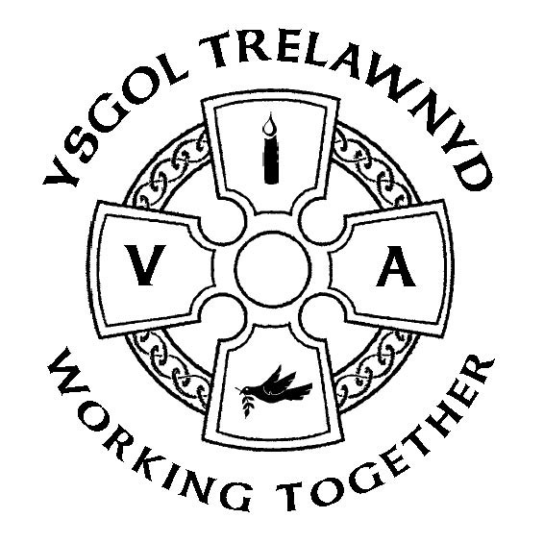

28th February 2020

It was lovely to see so many of you at the Fairtrade Coffee Morning this morning. Thank you for your kind donations of tea, coffee, cakes and raffle prizes.

Bara Brith Baking Challenge - open to everyone!
Entries to be submitted to the Criw Cymraeg on Monday 2nd March

Wednesday 4th March - The Ethos Council are arranging a Service to celebrate the Hindu festival ‘Holi’ – please can all children wear suitable clothes (not School uniform or their favourite outfit) for a ‘messy’ Collective Worship

There will be NO Singing Club on Wednesday 4th March

Before half term, we welcomed a visitor from The Buddhist Centre in Llandudno.
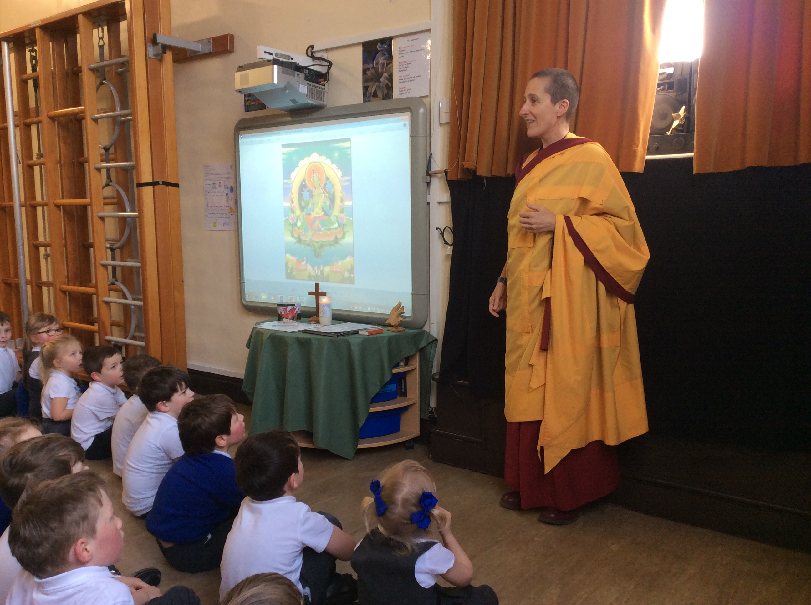

“On 11.2.20, in Service, we had a visit from a Buddhist nun. She came from Llandudno to tell us about the religion Buddhism. It’s the fourth biggest religion. She was wearing a skirt and a cloak made up of two layers. The skirt was to represent all the promises she made. For example, she promised not to kill, steal, lie, have a boyfriend, not to drink alcohol or take drugs. The cloak was to represent meditation and to get rid of all the bad thoughts. We noticed that she had shaved her head. We asked her why, and she said that you don’t have to be beautiful to be happy. She also showed us a picture of a Buddha and a temple in Lake District. A question came across us. Why did she become a Buddhist nun? She said that she was really rich, had nice long hair, had a husband and a sports car but she wasn’t happy, so she went to meditation class and really liked it. Over all everyone loved it and we want to learn more about different religions,” wrote Gabi in Y6.

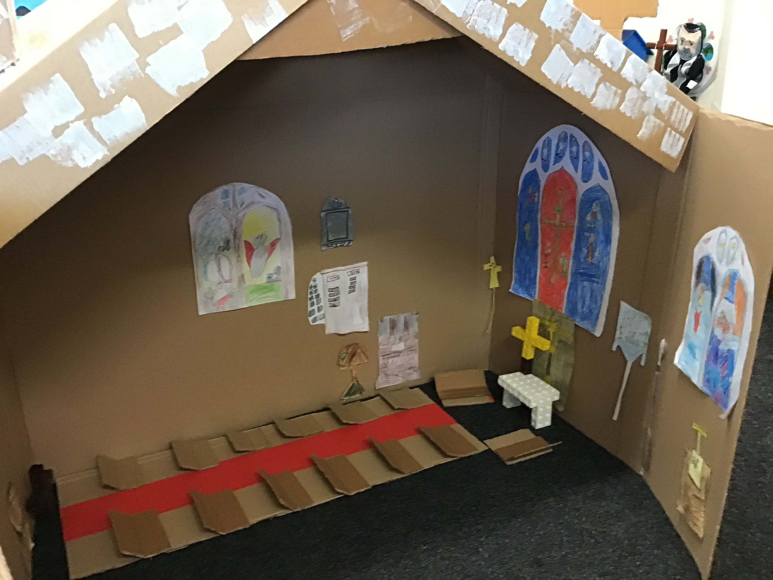
Years 1 and 2 have made a replica of St Michael and All Angels Church so they can sit inside and tell Bible stories to their friends.

Upcoming events:
March
Mon 2nd School Eisteddfod – wear Welsh colours or traditional costume
Mon 2nd Tales from Wales (pm)
Thu 5th PTA World Book Day / Fun Run
Tue 10th School photographs (pm)
Thu 26th Show and Tell 3pm for all classes except Y34
April
Thu 2nd PTA Bunny Drive / Own Clothes Day
Fri 3rd Y34 Easter Service, St Michael and All Angels 10.30am
Fri 3rd School closes
Mon 20th School opens
Tue 21st - Wed 22nd Y34 residential visit to Kingswood, Mold
Fri 24th Creative Schools Y34 Showcase at Theatr Clwyd
Mon 27th PTA meeting 6pm
National Tests April 28th - May 5th
May
Thu 7th PTA Disco
Fri 8th Bank Holiday
Thu 21st School closes for the half term break
June
Mon 1st Training Day
Tue 2nd School opens
Tue 16th Group photographs (pm)
July
Thu 2nd Y6 Cathedral Service, St Asaph
Thu 2nd Show and Tell 3pm
Tue 7th PHS Transition (Day 1)
Wed 8th Move up Day for all classes / PHS Transition (Day 2)
Fri 10th PTA Summer Event
Thu 16th Y6 Leavers’ Church Service / Afternoon Tea
Thu 16th School closes for the Summer break
Fri 17th Training Day
Mon 20th Training Day

