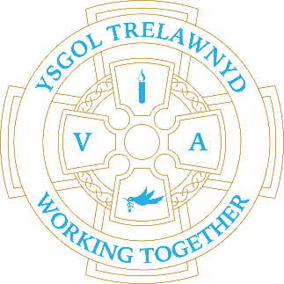
30th January 2023

Our dodgeball team demonstrated a great attitude at the Small Schools Tournament. Well done, everyone!

[Pictures removed for website edition]

Children and staff dodged the rain (nearly) on their walk up the Gop on the hunt for the Gruffalo or the Gruffalo’s Child.

[Pictures removed for website edition]

CYMRAEG YR WYTHNOS
Cymraeg plant: Wyt ti’n hoffi…?
Cymraeg oedolion: Mae’n amser cinio.

Dates for your diary:
Thu 2nd Feb: Rec/Y1/Y2 trip to Liverpool
Fri 17th Feb: Fairtrade Coffee Morning

[Pictures removed for website edition]

The children made cards and love spoons to celebrate Dydd Santes Dwynwen and have celebrated Chinese New Year with fortune cookies, lanterns and fans.

[Pictures removed for website edition]

School Clubs
Monday: Games Club
Tuesday: Craft Club
Thursday: Dodgeball Club

Cofion,
Marina Parsons
Pennaeth / Headteacher
01745 570171
trhead@hwbcymru.net

Before and After School Provision available - 01745 856683
Before School 8am-8.50am £2.00 / After School Until 5.30pm £9

Pre-loved uniform is available

Forms requesting holiday in term time are available from the class teachers or school office and should be completed in advance

Please inform school on the first day of absence 01745 570171 / trhead@hwbcymru.net

