30th April 2021
Sun Safe
It's that time of year again where hopefully the sun starts to shine more often than not. All classes will have lessons on how to keep safe in the sun. This year's resource involves the snappy phrase 'Wrap, Splat, Hat' - see above.
So, wear suitable clothes that are cool but keep you well covered, splat on the sun cream and wear a hat.
Please could you ensure that children come to school already wearing their cream if it's a sunny day and also bring a hat in order to keep cool in the sun.
They can bring a bottle of sun cream to re-apply if you think it necessary, but staff are not allowed to apply cream to any pupils.

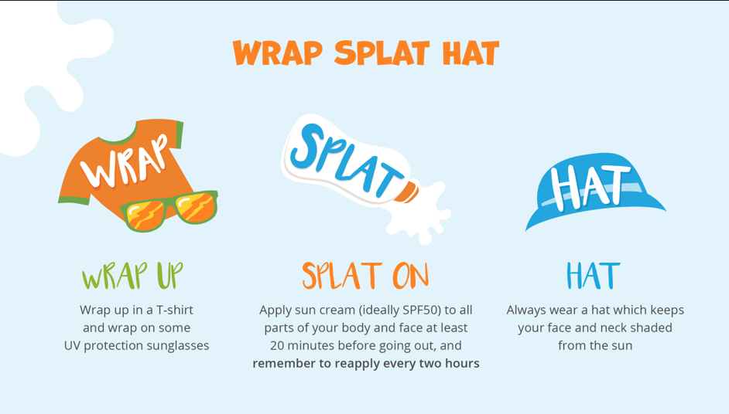

It is so important to protect children’s skin from exposure to the sun as it not only causes pigment changes, it also increases the risk of skin cancers.
Use high factor (ideally SPF50) sun creams which have broad spectrum protection with a high UVA rating. Apply sun cream at least 20 minutes before being in the sun. Make it fun and relaxed for children and look for formulations that are easy to rub on.
Make sure children are in the shade and avoid being out when the sun is strongest, usually between 11am and 3pm.
Don’t forget to pack plenty of water to stay hydrated.
Involve your child once they are old enough to put sun cream on.
(Taken from National Schools Partnership Sun Awareness Programme in association with Garnier Ambre Solaire)
We have received notification that essential works are being carried out by Welsh Water from 4th-6th May on London Road. There will be temporary signals and this may cause some inconvenience and delays.

Summer Term dates for your diary:
10th-14th May Target Setting phone calls – information to follow
28th May School closes for the half term break
7th June School re-opens
15th June School Photographs (provisional)

Please remember to contact the school office (01745 570171) to report your child’s absence.

Marina Parsons
Pennaeth / Headteacher
01745 570171
trhead@hwbcymru.net

[Pictures removed for website edition]

