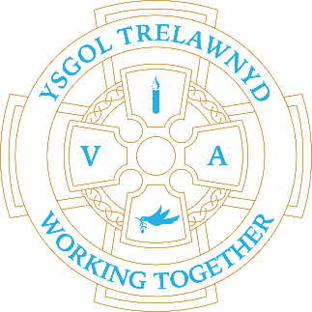
3rd October 2022

We have been enjoying the sights, sounds and tastes of Autumn in school.

[Pictures removed for website edition]

Cymraeg plant: Dw i’n licio…

Cymraeg oedolion: Ble mae…?

Dates for your diary:
7th October: Y12 Harvest Festival 2.30pm
Thank you for your donations - Harvest Collection deadline is 14th October
21st October: Show Racism the Red Card and wear red
26th October: Target Setting

Cofion,
Marina Parsons
Pennaeth / Headteacher
01745 570171
trhead@hwbcymru.net

Before and After School Provision available - 01745 856683
Before School 8am-8.50am £2.00 / After School Until 5.30pm £9

Pre-loved uniform is available

