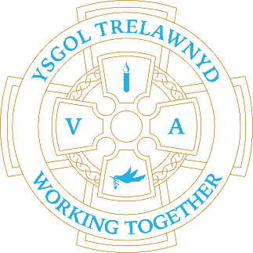
4th December 2023
It was great to see so many of you at Show and Tell last week - the children really enjoy sharing their learning with you all.

Thank you for your kind donations for the PTA Christmas Colours Raffle hampers. We would love for you to join us on Wednesday 13th December for a Victorian Carol Concert at the Memorial Hall 6pm-7pm. The PTA will be serving refreshments including festive mulled wine.

This week is the last week of School Clubs
Monday - Animation (Mr Williams)
Tuesday - Science (Mrs Richards)
Wednesday - Draw with Rob (and Mrs McNamara)
Thursday - Dance (Mrs Evans)

Dates for your diary:
7 / 12 Chester Zoo trip (letters have been sent home)
8 / 12 Christmas Jumper Day
13 / 12 Carol Concert at Memorial Hall 6pm-7pm
18 / 12 Y34 Christmas Play
19 / 12 FP (Rec-Y2) Christmas Play
20 / 12 Y56 Christmas Play
21 / 12 Early Years Nativity 10.30am at Llanasa Church
22 / 12 School closes for the Christmas holidays
10 / 1 / 2024 School opens for the Spring Term

Christmas Plays
Matinée Performance 2pm
Doors open 1.45pm
No refreshments are served

Evening Performance 6.15pm
Doors open 5.45pm
Refreshments served until 6.10pm

Cofion,
Marina Parsons
Pennaeth / Headteacher
01745 570171
trhead@hwbcymru.net

Pre-loved uniform is available

Forms requesting holiday in term time are available from the class teachers or school office and should be completed in advance.

Please inform school on the first day of absence 01745 570171 / trhead@hwbcymru.net

