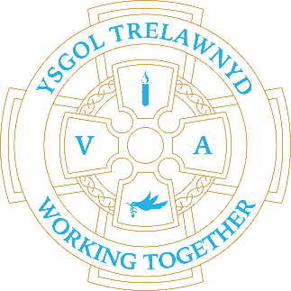
6th March 2023

PTA Disco – WOW! What a party! World Book Day – Sleepy bedtime stories

[Pictures removed for online version]

Eisteddfod

[Pictures removed for online version]

CYMRAEG YR WYTHNOS
Cymraeg plant: Pryd mae dy benblwydd di?
Cymraeg oedolion: Stopiwch!

Dates for your diary:
Thursday 9th March: Target Setting
Friday 10th March: PTA Own Clothes Day (Easter egg donation)
Wednesday 29th March: Show and Tell
Thursday 30th March: Y34 Easter Servie at Llanasa Church
Thursday 30th March PTA Easter Bingo

School Clubs
Tuesday: Shoebox Story Club
Thursday: Lego Club

Cofion,
Marina Parsons
Pennaeth / Headteacher
01745 570171
trhead@hwbcymru.net

Before and After School Provision available - 01745 856683
Before School 8am-8.50am £2.00 / After School Until 5.30pm £9

Pre-loved uniform is available

Forms requesting holiday in term time are available from the class teachers or school office and should be completed in advance

Please inform school on the first day of absence 01745 570171 / trhead@hwbcymru.net

