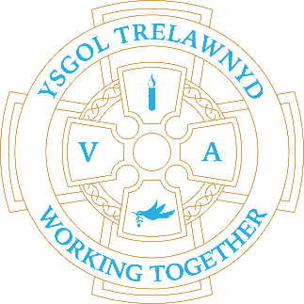
9th May 2023

There will be a Parent and Carer Meeting with the Estyn Inspection Team today at 3.45-4.45 in the School Hall. Childcare will be provided.

Reminder from the Ethos Council
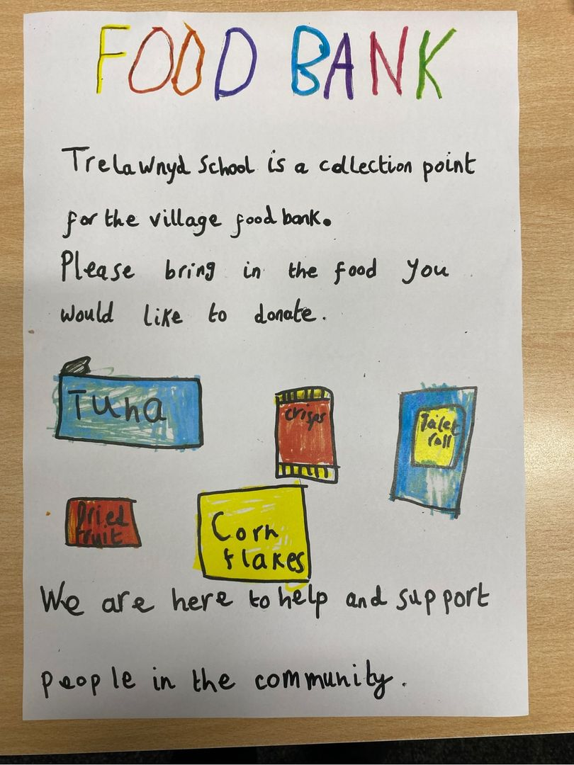

Early Years Tea Party (milk and crumpets) for The Coronation of King Charles III and to celebrate our own VIP day

[Pictures removed for website edition]

The Early Years enjoyed their first Forest School session.
Please remember coats and wellies this Wednesday, too, Nursery and Reception.
Wet weather doesn't stop Forest School!

[Pictures removed for website edition]

Welsh Language Classes with Mr Williams every Wednesday in The Hut
11.30am -12pm / 2.30pm - 3pm
Cymraeg yr wythnos:
Cymraeg plant: Bechod!
Cymraeg oedolion: Mae’n amser mynd adref.

The ECO Council have purchased a new recycling bin for the yard.

[Pictures removed for website edition]

PTA Meeting
Wednesday 17th May at 3.15pm in the School Hall
Current standing members can express their interest by email if unable to attend

DATES FOR YOUR DIARY
wc 15 May - Test Week
Wed 17 May PTA meeting 3.15
Thu 18 May - Movie Night 3.30-5
Fri 26 May - School closes
Tue 6 June - School re-open
SCHOOL CLUBS
Tuesday: Yoga and Aerobics Club
Wednesday: Sports Club
Thursday: Comic Book Club

Cofion,
Marina Parsons
Pennaeth / Headteacher
01745 570171
trhead@hwbcymru.net

Before and After School Provision available - 01745 856683
Before School 8am-8.50am £4 / After School Until 5.30pm £12
Please note Tiny Tots new charges applicable from Monday 17th April

Pre-loved uniform is available

Forms requesting holiday in term time are available from the class teachers or school office and should be completed in advance

Please inform school on the first day of absence 01745 570171 / trhead@hwbcymru.net

