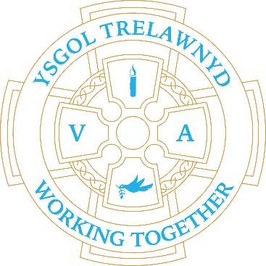
11th October 2021

Harvest Food Collection: The School Council are collecting non-perishable food items for Harvest. These will be donated to a local food bank. If you wish to donate, please send items in with your child. Thank you, The School Council

Dates for your diary:
18/10 3.30-6.30 Target Setting for Nursery and Reception (Miss Jones)
19/10 3.30-6.30 Target Setting for Years 1 and 2 (Miss Hughes)
20/10 3.30-6.30 Target Setting for Years 3 and 4 (Mr Williams)
21/10 3.30-6.30 Target Setting for Years 5 and 6 (Miss Fisher)
22/10 PTA Fancy Dress Sponsored Daily Mile

Cofion,
Marina Parsons
Pennaeth / Headteacher
01745 570171
trhead@hwbcymru.net

Craft Club fun!

[Picture removed for website edition]

