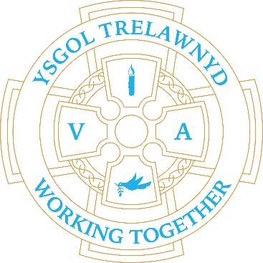
13th December 2021

Christmas is on its way!
Ysgol Trelawnyd VA School’s Christmas Craft Fair will take place in the outdoor classroom this week 🎄✨. We welcome all parents / carers to come along and buy something truly individual this Christmas! Proceeds will go to school.
Foundation Phase items for sale - Wednesday 15th from 3pm
KS2 items for sale - Thursday 16th from 3pm
(If there is anything left) Foundation Phase & KS2 - Friday 17th from 3pm
The children have been working so hard and are very proud of the products they have created. See photos below:

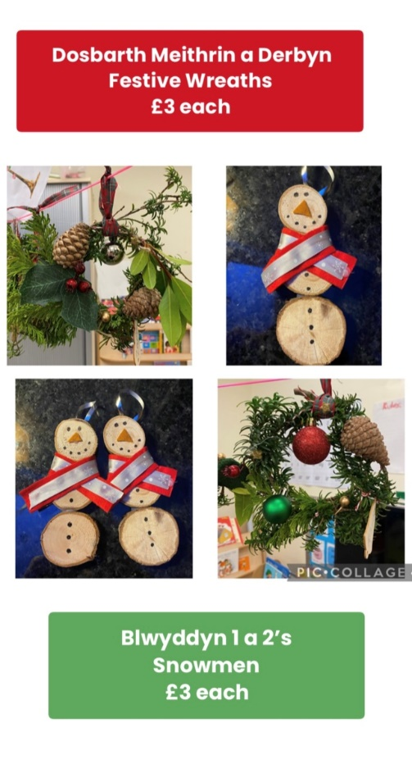
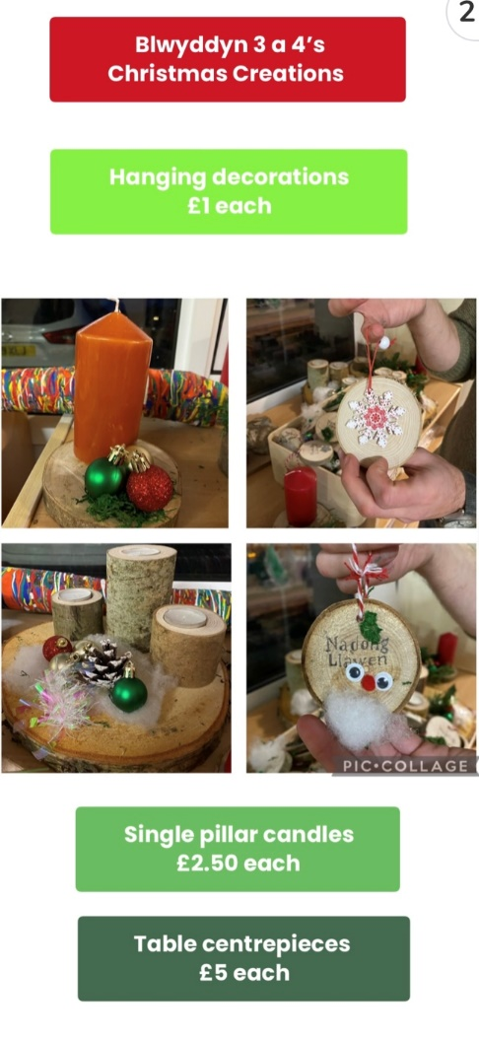
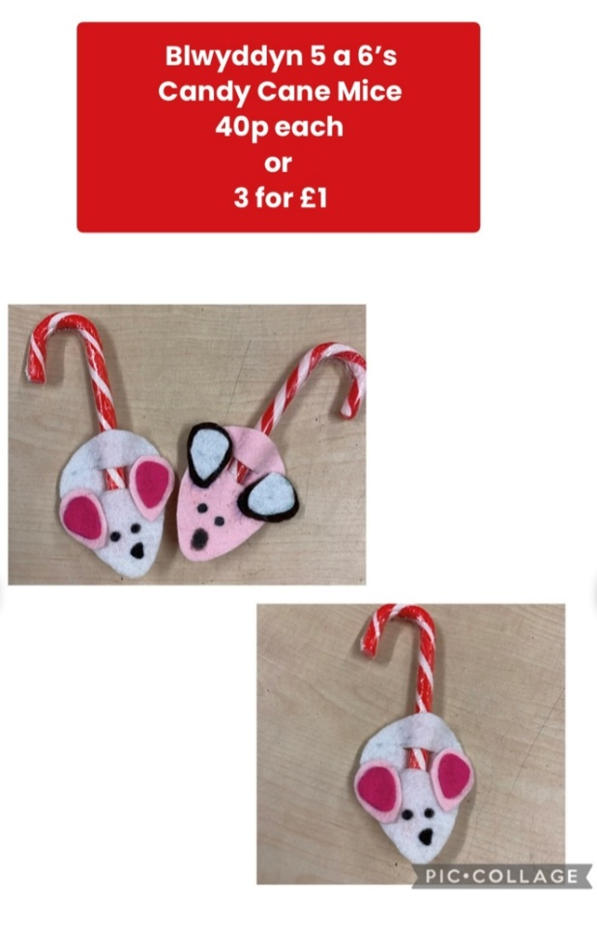

We look forward to seeing you there!
(Due to social distancing measures, only one customer will be able to enter the outdoor classroom at a time. If you could form a distanced queue it would be much appreciated ☺️)

Friday 17th is Christmas Pyjama Day (this is a School Council alternative to Christmas Jumper Day); however, the children can wear anything Christmas… pyjamas, jumpers, hat, a bit of tinsel… Donations will go to School Council projects.

PTA Christmas Party
The PTA are planning class parties for the children on Monday 20th December. I have been told some elves may visit on behalf of Santa and Mrs Claus during the afternoon.

[Picture removed for website edition]

An Advent Service with Reverend Lewis

School Meals
The children enjoyed the Christmas Lunch last Wednesday.

[Picture removed for website edition]

Newydd provide two hot meal choices, jacket potatoes - cheese, tuna, beans, cheese and beans, pasta pots and sandwiches – ham, cheese, tuna (white or brown bread available) daily.

Arts Council for Wales Grant
Our Early Years children will be learning about the Welsh language, history and culture to create a unique display that can be enjoyed by all. Funding for this project has been approved by The Arts Council of Wales.
The school will be creating a permanent outdoor 'Croeso' display for the main entrance of our school. This will be made with the children to welcome pupils, parents and visitors and embed our use of the Welsh language.
Attendance and Punctuality
It is our responsibility to ensure that we actively promote and encourage outstanding school attendance for all of our children. Absence from school is always a priority for us and during Autumn Term monitoring with the Attendance Officer we have identified that 21% of children have attendance below 85% (excluding the impact of Covid19).

Although being absent cannot always be helped as we all do become ill from time to time, please take a look at the table which shows how much time your child could be missing.
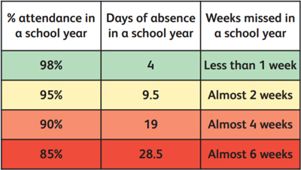

Good attendance is vital for children to feel settled within school and in order for them to make good progress from wherever they currently are with their learning. Our school attendance target for this year is 96%.

We welcome your support in ensuring good attendance by keeping any term time absence to an absolute minimum and arranging appointments, other than emergency ones, outside of school hours wherever possible.

After School Clubs for the Spring term (w/c 10th January for 10 weeks)
M – Gardening (Miss Fisher)
T – Disney Club (Miss Jones)
W – Sports (Miss Hughes)
Th - Clwb Carioci Cymraeg (Mr Williams)
F – Construction (6 weeks only) (Miss Parsons)

Cofion,
Marina Parsons
Pennaeth / Headteacher
01745 570171
trhead@hwbcymru.net

School-based Before and After School Provision: 01745 856683

