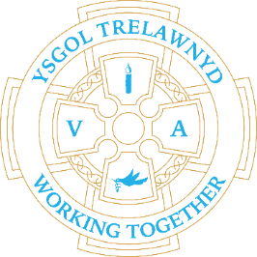
14th February 2022
Road Safety
All classes will have refresher sessions on Road Safety and we will ask for the support of our PCSO. The safety of all children and staff must be considered as paramount at all times and the number of incidents related to traffic on London Road during morning drop off and afternoon pick up has risen.
I am aware parents are investigating traffic calming measures which may reduce or prevent incidents, such as the one last week, from occurring; and the issue will be discussed with the Governing Body and at the Community Council.
In the meantime, the following can be avoided:
Parking too near a corner or junction preventing other drivers from having a clear view
Parking near solid white lines which are used to indicate a hazard
Parking near a dropped kerb
Parking on or opposite the yellow zig zag lines outside of school
Parking on the brow of a hill
Parking near a bend
Parking in front of residents’ driveways
As a pedestrian, not using the vehicular access to the school car park
Thank you for your consideration and co-operation with this important matter.

KS2 enjoyed a Flag Football workshop this week

(Pictures removed for website edition)

School Lunches: Week 3

School Clubs
After-school activities for Years 1-6 will resume after the half term break; school clubs run until 4pm.
Monday - Gardening (Miss Fisher)
Tuesday - Disney Club (Miss Jones)
Wednesday - Games Club (Miss Hughes)
Thursday - Clwb Carioci Cymraeg (Mr Williams)

Cymraeg yr wythnos:
Children: Esgusodwch fi
Adults: Hyfryd

Criw Cymraeg have planned activities for Wythnos Cymraeg the week we return to school. The children can wear traditional costume on Tuesday 1st March
Wear Welsh colours to school on Friday 4th March!

Applications for Nursery September 2022 can be made until this Friday - 18th February https://www.flintshire.gov.uk/en/Resident/Schools/School-Admissions.aspx

Cofion,
Marina Parsons
Pennaeth / Headteacher
01745 570171
trhead@hwbcymru.net

