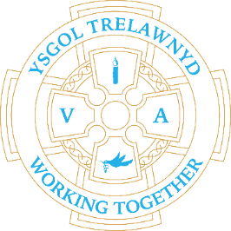
14th March 2022
Fairtrade
Diolch yn fawr to everyone who donated prizes and cakes and also to everyone who attended our Fairtrade coffee morning! ☕️ We are blown away by your support and are very excited to announce that we have raised £95.90 for our Eco funds! Wow! The Eco Council have lots of ideas to improve our school and outdoor area with the money raised 👍

[Pictures removed for website edition]

School Lunches: Week 3

Staff news: Congratulations to Mrs Richards who has achieved HLTA status. Da iawn!

Now the scaffolding has been removed the lower route into school is now accessible again. We will continue to dismiss the children from the yard at the end of the day.

Cofion,
Marina Parsons
Pennaeth / Headteacher
01745 570171
trhead@hwbcymru.net

