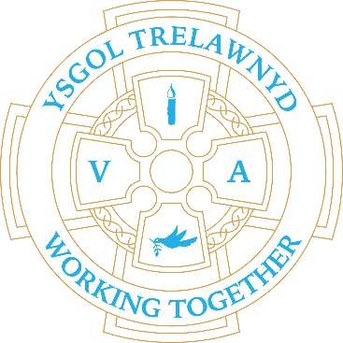 [Picture removed for online edition]
17th December 2021

Although we haven’t been able to host audiences, the Christmas performances have all gone really well. I hope that you have enjoyed viewing them with your children and families. You will also be able to share any links with other family members and family who wouldn’t normally be able to see the shows. The confidence and performances of the children have been wonderful. I would like to say a huge thank you to all of the staff who have helped put the Christmas performances together for our children. There is always so much work that goes into these behind the scenes and I’m sure that the children really appreciate all you have done.

Despite the ongoing challenges this term, I have been proud of what we have achieved. We have managed to operate with some level of normality and maintain a level of broad experiences and kept the content of the children’s learning as rich as possible. We have also managed to host workshops and sports coaches which the children have enjoyed.

I would like to thank you all for your support during the course of the year and particularly this term. It has again been a year like none of us have experienced before and this doesn’t look like changing soon. We will continue to adapt and adjust to the situation and make decisions based on the best interests of our children, staff and families.

The Minister’s announcement yesterday does not impact on the date we had planned to open for the children (10th January); however, the two planned INSET days on 6th and 7th January will become planning days and the INSET days moved to later in the year. These dates will be decided by the Holywell Cluster and shared with you as soon as possible.

Restrictions such as the one-way system, staggered start and finish to the school day, etc may be re-instated. Schools are expecting further guidance and Local Authority updates between Christmas and New Year. I will keep you informed, via SeeSaw, as information is received.

Have a wonderful Christmas break with your families and a peaceful New Year. I look forward to seeing you all again on 10th January 2022!

Cofion,
Marina Parsons
Pennaeth / Headteacher
01745 570171
trhead@hwbcymru.net

