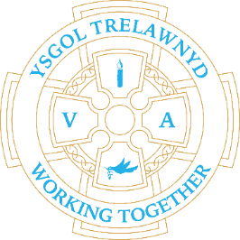
20th June 2022

Healthy Eating Week

[Pictures removed for website edition}

School Lunches: Week 2

Please return your nominations for Parent Governor by Thursday 23rd
The form has been shared on SeeSaw

Dates for your diary
Tuesday 21st June Foundation Phase Sports Day at 9.15am
Wednesday 22nd June Key Stage 2 Sports Day at 1.30pm
SCHOOL CLUBS FINISH ON 30TH JUNE
Tuesday 5th July Show and Tell (Reception and Years 3 and 4)
Wednesday 6th July Move up Day (all classes)
Thursday 7th July Show and Tell (Years 1 and 2 / Years 5 and 6)
Friday 8th July Clean-up Day 3pm-5pm YOUR ECO COUNCIL NEEDS YOU!
Tuesday 12th July Nursery induction
Wednesday 13th July whole school trip
Friday 15th July Y6 Leavers’ Service at 2.30pm
Monday 18th July Y6 Leavers’ treat day
Tuesday 19th July School closes

Cofion,
Marina Parsons
Pennaeth / Headteacher
01745 570171
trhead@hwbcymru.net

