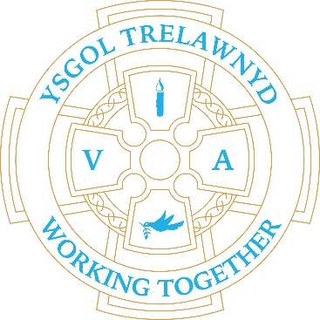
22nd November 2021

Next week (wc 29th Nov) will be the last After School Club sessions for this year.
Clubs will resume in the Spring term.

The children raised £90 for Children in Need. Thank you for your support.

Please do not use the school car park. The school car park is for staff, visitors and school transport vehicles only. Parents who use out of school provision are able to use the car park before 8.30 and after 3.30 only. Please do not use the car park between school hours.

It has been lovely to welcome Reverend Lachlann-Waddell and Reverend Harvey for Collective Worship since the beginning of November. The children are enjoying being (partly) back together for these services.

Cofion,
Marina Parsons
Pennaeth / Headteacher
01745 570171
trhead@hwbcymru.net

School-based Before and After School Provision: 01745 856683

