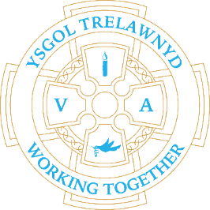
23rd May 2022

A busy week - a visit from PC Manus about digital safety, a Justice workshop delivered by Theatr Clwyd for Years 5 and 6 - where we met PC Thompson, a Tennis workshop

[Pictures removed for online edition]

School Lunches: Week 2
Thursday will be Friday’s choices as Friday is the Jubilee Picnic Lunch

Dates for your diary
26th May Foundation Phase trip to RSPB Conwy
15th June School photographs
21st June Foundation Phase Sports Day
22nd June Key Stage 2 Sports Day
wc 4th July Show and Tell

Cofion,
Marina Parsons
Pennaeth / Headteacher
01745 570171
trhead@hwbcymru.net

Trelawnyd Community Association
Invite you to celebrate

The Queen's Platinum Jubilee 2022

Street Party 4th June 2pm to 5pm
Chapel Street, Trelawnyd.

Rhyl Silver Band
Children’s entertainment
and refreshments

