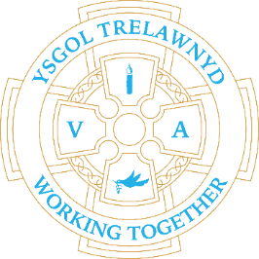
27th June 2022

[Pictures removed for website edition]

Preparing and delivering home grown vegetables to the community

School Lunches: Week 3

Dates for your diary
SCHOOL CLUBS FINISH THIS WEEK
Tuesday 5th July Show and Tell (Reception and Years 3 and 4)
Wednesday 6th July Move up Day (all classes)
Thursday 7th July Show and Tell (Years 1 and 2 / Years 5 and 6)
Friday 8th July Clean-up Day 3pm-5pm
Tuesday 12th July Nursery induction
Wednesday 13th July whole school trip
Friday 15th July Y6 Leavers’ Service at 2.30pm
Monday 18th July Y6 Leavers’ treat day
Tuesday 19th July School closes

Cofion,
Marina Parsons
Pennaeth / Headteacher
01745 570171
trhead@hwbcymru.net

