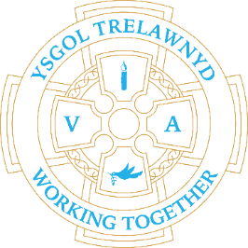
28th March 2022
Residential Visit to Pentrellyncymer
What lovely weather was had by all last week! The Centre staff were impressed with how enthusiastically the children, and adults, participated in all the activities and commented on how responsible they were - what a delightful group of children!!

[Pictures removed for website edition]

At school we also enjoyed time outdoors for our Wellbeing Week

[Pictures removed for website edition]

School Lunches: Week 2

Cofion,
Marina Parsons
Pennaeth / Headteacher
01745 570171
trhead@hwbcymru.net

