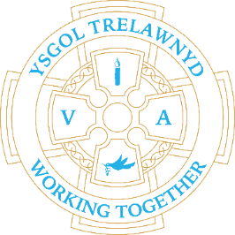
31st January 2022

All classes enjoyed the RSPB Big Birdwatch last week, spotting many different species visiting our school grounds. I am sure the delicious bird feeders, made by the Early Years, helped to attract them, or maybe it was our tidy school grounds, thanks to the Eco Council’s litter picking.
(Picture removed for online edition)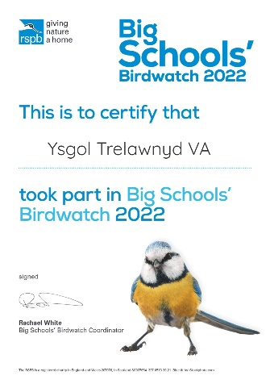

This week, Years 5 and 6 enjoyed an AURA Badminton session. We are hoping to restart school clubs after half term.

Attendance:
Nur/Rec: 86.8%
Yr 1 & 2: 91.7%
Yr 3 & 4: 93.4%
Yr 5 & 6: 92.3%

Week 1 school lunches this week; please note Tuesday 1st February is Chinese New Year Theme Day.

Criw Cymraeg / Cymraeg yr wythnos:
Sut mae’r tywydd?
Bendigedig!

Cofion,
Marina Parsons
Pennaeth / Headteacher
01745 570171
trhead@hwbcymru.net

Applications for Nursery September 2022 can now be made until 18th February https://www.flintshire.gov.uk/en/Resident/Schools/School-Admissions.aspx

