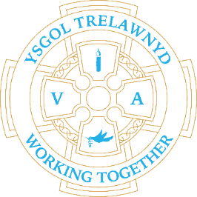
4th April 2022
Locality Project / Welsh in the Outdoors
We have been ‘out and about’ and had some visitors this week.

Trelawnyd Male Voice Choir

[Pictures removed for website edition]

Mrs Bagguley, our governor, came to visit us today to answer all of the questions we had about Trelawnyd and how it has changed over the years. We found out lots of interesting information about Trelawnyd and her life growing up in the village.

[Pictures removed for website edition]

Working outdoors

[Pictures removed for website edition]

Visit to The Gop

[Pictures removed for website edition]

School Lunches: Week 3
Price increase from 4/4/2022 - £2.50
Online ordering still unavailable - apologies for any inconvenience caused

School Clubs from wc 9th May
Monday - Gardening
Tuesday – Disney
Wednesday – Construction
Thursday - Animation (Welsh folk tales)

Staff news
We say goodbye to Mrs Hoose on Thursday and wish her the very best for her future adventures!

Reminder
25th April is Training Day

Cofion,
Marina Parsons
Pennaeth / Headteacher
01745 570171
trhead@hwbcymru.net

