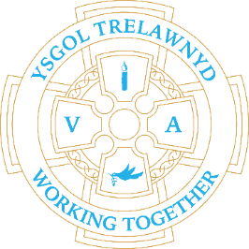
7th February 2022
Year 1 and 2 artists practising their skills.

[Pictures removed for website edition]

We are enjoying weekly services with Reverend Lewis, Reverend Harvey and Reverend Lachlann-Waddell.

[Pictures removed for website edition]

Week 2 school lunches this week
After half term the preferred payment method for school lunches will be online through the School Gateway. We have received notice that, in the near future, FCC will no longer be accepting cheques as payment for school meals and from Easter all payments will be online.

Cymraeg yr wythnos:
Ga i helpu?
Beth sy’n bod?

Cofion,
Marina Parsons
Pennaeth / Headteacher
01745 570171
trhead@hwbcymru.net

Applications for Nursery September 2022 can be made until 18th February https://www.flintshire.gov.uk/en/Resident/Schools/School-Admissions.aspx

