Claire Homard  Chief Officer (Education and Youth)  Prif Swyddog (Addysg ac leuenctid) | 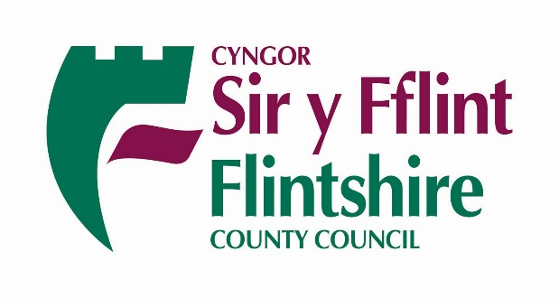
 | Your Ref/Eich Cyf
 | Our Ref/Ein Cyf | CH
 | Date/Dyddiad | 26.3.2020
 | Ask for/Gofynner am | Claire Homard
 | Direct Dial/Rhif Union | 01352 704190
Dear Parents & Carers

Changes to Childcare Provision in Flintshire from Monday March 30th 2020
From Monday 30th March Flintshire County Council will be changing its model for the provision of childcare for key workers and vulnerable learners. The Council will operate a smaller number of strategically located primary, secondary and special school hubs, close to major traffic routes in both urban and rural areas.
There will be 12 area hubs made up of 22 school sites. School buildings have been chosen due to their location, their size and their classroom layout, and also to ensure a spread of provision across the County within easy reach.
Local schools will work together to run the childcare in the area hub. This will enable them to redeploy and rota teaching and support staff to take care of the children. This model also allows the Council to re-prioritise its catering and school transport services to support the children accessing the hubs.

The hubs will operate from 8.00 a.m. – 5.30 p.m. Monday to Friday. Children will be fed free of charge – breakfast, lunch and a light afternoon snack. Most parents will be able to drop off and collect their children, but if this is not possible, the Council can arrange transport on request. Arrangements for the school holidays are currently being considered.

We can assure parents that having fewer sites does not mean larger groups of children together. Schools will have plans in place to keep children in the hub sites in very small groups in classrooms, and during break and meal times. They will ensure that social distancing guidelines are followed

Being in a new building that they are not familiar with is something parents and children might be anxious about. Wherever possible, children from the same school will be put together in the small groups, so there will be someone they know. Staff from each local school will also be working in their area hub so there should be friendly faces the children will recognise and be comforted by.
As this is a childcare provision and not statutory education, there will be no separate hubs for Welsh medium or for faith. Usual practices around the safeguarding of children will continue.
Each individual school will manage the booking process for parents so they will know who to expect each day, and to ensure that individual needs are met. Parents will be asked to complete a simple registration form with essential details. Schools will be contacting parents directly with the details of how to book places.
We anticipate that parents will probably use their nearest hub but if another hub is more convenient because of travel routes, they can access places there and will be supported by their ‘home’ headteacher to do so.
The list of school sites designated as hubs are listed at the end of this letter.
If you still have concerns or queries you should now direct them to your ‘home school’ headteacher who is fully briefed and ready to support you.
The Council is confident that this is the most sustainable and resilient model to deliver this much needed childcare, and will provide the resources to make them a success.

Yours sincerely
Claire Homard Chief Officer Education & Youth
Colin Everett Chief Executive, Flintshire County Council
Cllr Ian Roberts Leader of Flintshire County Council & Cabinet Member for Education

 | Area | Hub sites
1 | Buckley | Elfed High School  Mountain Lane CP
2 | Mold | Alun School  Ysgol Maes Garmon  Ysgol Bryn Coch
3 | Flint | St Richard Gwyn Catholic High School  Gwynedd CP
4 | Holywell | Ysgol Treffynnon  Ysgol Maes y Felin
5 | Connah’s Quay | Connah’s Quay High School  Ysgol Bryn Deva
6 | Hope | Castell Alun High School  Ysgol Estyn
7 | Hawarden | Hawarden High School  Sandycroft CP
8 | Saltney/ Broughton | St David’s High School  Broughton CP
9 | Rural | Ysgol Gronant
10 | Rural | Ysgol Esgob, Caerwys
11 | Shotton | Ysgol Ty Ffynnon
12 | Queensferry | Queensferry Campus (CP and Plas Derwen)

