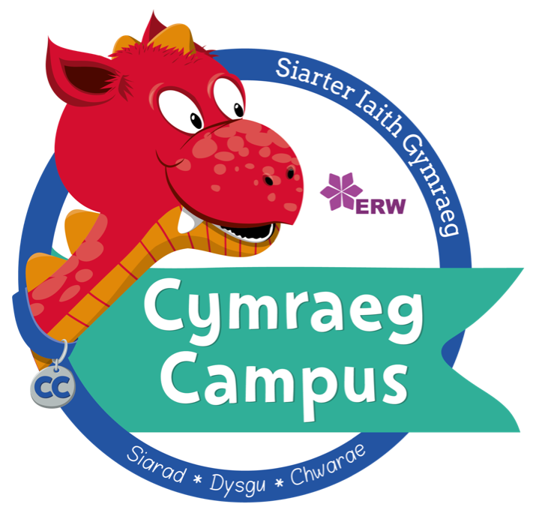

Ysgol Trelawnyd began the Cymraeg Campus language charter in February 2018 and received their Bronze award in July 2019. Over the challenging last two years, the school has successfully maintained, adapted and even improved the outcome of some of the targets and are praised for this.

The school has a positive Welsh ethos throughout, which goes beyond the visual ethos expected of the award. Welsh is displayed in classes and all other areas and there’s a large, striking Croeso mural outside. The reception area reflects a contemporary vision of Wales and there’s a QR code on the signing in book with a bilingual croeso message from a member of the Criw. The Criw Cymraeg report on the school’s progress with the Language Charter through updates on the school’s newsletter and during the Welsh assemblies. Parents can see progress regularly on Seesaw and are constantly informed about Welsh activities in the community and online.

Cwricwlwm Cymreig is clearly planned for with a whole school overview using Cwricwlwm Maestro which has a Welsh dimension in each theme. Seesaw clips demonstrate how pupils confidently sing the anthem and Welsh hymns and the school recently invited Trelawnyd male voice choir to come in and sing with them. Pupils can confidently converse on the benefits of learning Welsh in school assemblies and on recordings on Seesaw. Parents are invited to the class ‘show and tell’ where they view Welsh activities and the school has established a link with Ysgol Mornant.

Helpwr Heddiw/C’mon Cymraeg is established throughout the school and Talk for Writing is also well established as a method of teaching Welsh. Everyday Welsh is used by all staff and the TAs have been given training on the alphabet and key phrases using the Language Continuum. The school has a very productive Criw Cymraeg who have worked on a number of projects to encourage the use of Welsh outside the classroom including the graffiti walls and the ‘Shed Cymraeg’ with a video created to show other pupils how to use the resources. The use of Welsh outside the classroom is a particular strength and the school participated in the Wales Outdoor Learning Week and were also part of the small schools project, working with Tom from the Urdd to use Welsh in different outdoor activities. Pupils used the Actionbound app to record their Welsh activities outside and were then able to review learning back in class.

Criw Cymraeg are responsible for leading the majority of the weekly Welsh assembly and are very proud of this and has given them a lot of confidence. The Lord’s Prayer is said in Welsh and pupils sing Welsh songs and hymns enthusiastically. The Criw introduce the phrase of the week and reward the winners - one for pupils and one for staff. They have created a calendar for the phrases of the week so that they’re organized for the year! During our visit we watched a video demonstrating what the Criw had achieved over the year, followed by each member telling us what they’d enjoyed most about being a member, what they were most proud of and targets for next year’s Criw!

The use of IT is still a strength in the school and was especially useful during lockdown to share evidence with parents. Detailed evidence such as I-movies, visual displays, notes and a variety of photographs have been kept by the Cymraeg Campus co-ordinator on SeeSaw to support the school’s progress within each of the ten targets. Campau Cosmig is still a favourite app with everyone and the TAs have been trained on how to use it. The school also make extensive use of other apps such as puppet pals and Actionbound in their Welsh activities and also have a designated green screen which was used during the Welsh Folk Tale club.

|  |  |
| --- | --- |
| Ysgol / School | Ysgol Trelawnyd |
| Dyddiad / Date | 29 Mehefin 2022 |
| Swyddog / Officer | Sharon Jones |

ADRODDIAD GWOBR ARIAN

SIARTER IAITH CYMRAEG CAMPUS

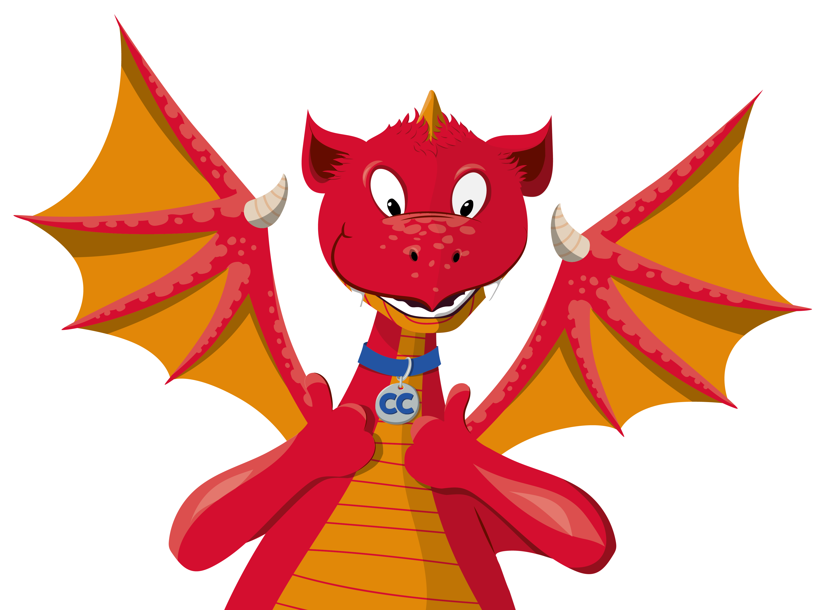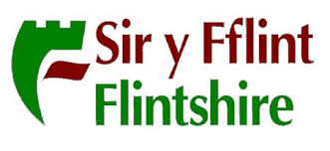

The school have been very proactive in taking part in the online Menter Iaith eisteddfods and the Criw Cymraeg have organised many events to celebrate Dydd Gŵyl Dewi, Dydd Miwsig Cymru and Santes Dwynwen. There has always been an emphasis on Welsh when creating and selling products for enterprise activities such as Christmas decorations and photo frames.

Pupils have regular guided reading sessions with records kept and Year 6 have been reading with Year 2 pupils and conducting a question and answer session with them. Through the cluster group, the school has been trialling the use of Tric a Chlic phonics resource that focuses on the Welsh alphabet sounds and guided reading. The resources have been added to SeeSaw so that teachers can set them for home reading. Pupils have access to iBooks on Giglets and they all have their own Welsh reading book on there.

Welsh is clearly visible on many displays and there is evidence of Welsh cross-curricular work undertaken in pupils’ topic books. Pupils evaluate their work at an appropriate level in Welsh using ‘Dwy Seren a dymuniad’ and aspects of P.E is taught in Welsh in all classes.

The school has succeeded in meeting the success criteria for each target and has achieved the *Gwobr Arian.* Good practice was observed and the staff are aware of the need to fully embed and develop each initiative in order to achieve the *Gwobr Aur*.

*Llongyfarchiadau a phob lwc!*

YSGOL TRELAWNYD

**Arian reading**

Mehefin 2022



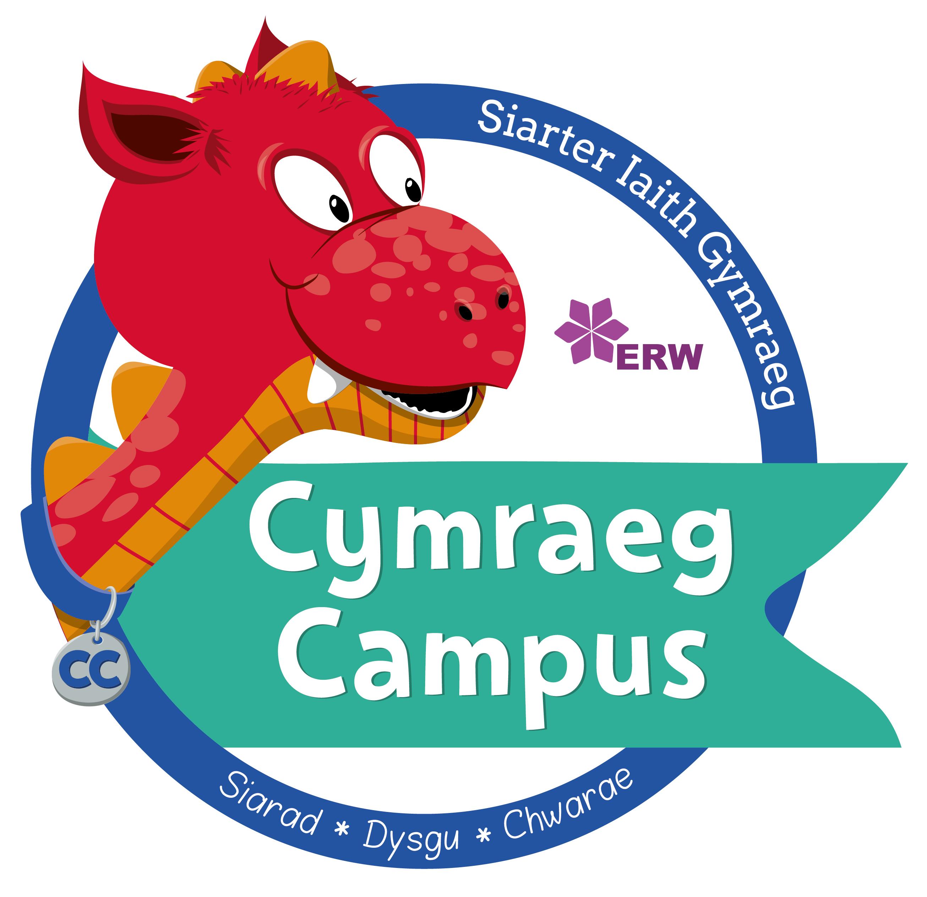

|  |  |  |
| --- | --- | --- |
|  | ✓ | X |
| Wedi llwyddo:  Passed: | **√** |  |

